

**INTERNAL REGULATION**

**OF**

**INSTITUTE OF STATISTICS**

**2019**

*(Regulation of INSTAT approved by Decision no. 5, dated 09.07.2019 of the Steering Board, amended by Decision no. 7, dated 04.07.2022, Decision no. 5, dated 08.07.2024 of the Steering Board, and Decision no. 7, dated 23.09.2024 of the Steering Board)*

*Updated*

**Contents**  
**CHAPTER I .**............................................................................................................................................5 **GENERAL PROVISIONS** ..................................................................................................................... 5  
Article 1 – Mission and Vision of INSTAT ............................................................................................. 5  
Article 2 – Object and Scope of Application ............................................................................................ 5  
**CHAPTER II – STRUCTURE OF INSTAT** .......................................................................................... 6  
Article 3 – Institutional Structure and Management ................................................................................. 6  
Article 4 – Governing and Advisory Bodies ............................................................................................. 6  
4.1. Director General ................................................................................................................................. 6  
4.2. Steering Board .................................................................................................................................... 7  
4.3. Statistical Council .............................................................................................................................. 7  
Article 5 – Constituent Units of the Organizational Structure .................................................................. 8  
5.1 Secretary General ................................................................................................................................ 8  
5.2 General Directorates and their Constituent Directorates ..................................................................... 9  
5.2.1 General Directorate of Statistical Production ................................................................................... 9  
5.2.1.1 Directorate of Social Statistics .................................................................................................... 10  
5.2.1.2 Directorate of National Accounts ................................................................................................ 10  
5.2.1.3 Directorate of Economic Statistics .............................................................................................. 11  
5.2.1.4 Directorate of Sectoral Statistics ................................................................................................. 11  
5.2.1.5 Directorate of Agricultural and Environmental Statistics ........................................................... 12  
5.2.2 General Directorate of Information Technology and Data Collection ........................................... 12  
5.2.2.1 Directorate of Information Technology ...................................................................................... 13  
5.2.2.2 Directorate of Regional Statistics and Geoinformation .............................................................. 13  
5.2.2.2.1 Regional Statistical Offices ..................................................................................................... 14  
5.2.3 *General Directorate of Coordination, Projects and Communication* ............................................ 16  
5.2.3.1 *Directorate of SKS Coordination, Approximation and Projects* ................................................ 16  
5.2.3.2 *Directorate of Communication and Publications* ....................................................................... 17  
5.2.4 *Directorate of Human Resources, Finance and Support Services* ................................................. 18  
5.2.5 Internal Audit Sector ...................................................................................................................... 18  
5.2.6 *Foreign Relations and European Integration Sector* ...................................................................... 19  
**CHAPTER III – INSTAT PERSONNEL** ................................................................................................ 20  
Article 6 – Composition ........................................................................................................................... 20  
Article 7 – Recruitment of Civil Servants ................................................................................................ 20  
Article 8 – Release and Dismissal of Civil Servants ................................................................................ 21  
Article 9 – Professional Ethics of Employees .......................................................................................... 22  
Article 10 – Official Working Hours ....................................................................................................... 24  
Article 11 – Absence from Work ............................................................................................................. 24  
Article 12 – Obligation to Fulfill Professional Duties ............................................................................. 25  
Article 13 – Annual Leave ....................................................................................................................... 25  
Article 14 – Professional Training ........................................................................................................... 26  
Article 15 – Participation in Unions and Other Organizations ................................................................ 26  
Article 16 – Other Rights ......................................................................................................................... 27  
Article 17 – Leave for Teaching .............................................................................................................. 27  
Article 18 – Violations and Disciplinary Measures ................................................................................. 28  
Article 19 – Authority and Procedure for Disciplinary Measures ........................................................... 28  
Article 20 – Expiration of Disciplinary Measures ................................................................................... 28  
Article 21 – Employment Contracts for Non-Civil Servant Employees ................................................. 28  
Article 22 – Employee Rights and Obligations ....................................................................................... 29  
Article 23 – INSTAT Obligations ........................................................................................................... 30  
Article 24 – Termination of Employment Contract ................................................................................ 30  
**CHAPTER IV** ............................................................................................................................................. 31  
**DATA DOCUMENTATION FOR PERSONNEL** ..................................................................................... 31  
Article 25 – Personnel File .......................................................................................................................... 31  
Article 26 – Civil Servant Evaluation ......................................................................................................... 31  
Article 27 – Recording Training in the Personnel File ............................................................................... 32  
**CHAPTER V** ............................................................................................................................................... 32  
**INSTAT STAFF TRAINING** ...................................................................................................................... 32  
Article 28 – Training Strategy ..................................................................................................................... 32  
Article 29 – Annual Training Implementation Plan .................................................................................... 33  
Article 30 – Transfer of Knowledge from Training or Internship ............................................................... 33  
Article 30/1 – Long-term Trainings Abroad ................................................................................................ 34  
**CHAPTER VI** .............................................................................................................................................. 34  
Article 31 – Conflict of Interest and its Avoidance ..................................................................................... 34  
Article 32 – Confidentiality ......................................................................................................................... 35  
Article 33 – Public Information ................................................................................................................... 36  
Article 34 – Deadlines for Processing Correspondence .............................................................................. 36  
Article 35 – Administrative Documents Received by INSTAT and Their Review .................................... 37  
Article 36 – Administrative Documents Not Registered or Submitted to the *Protocol Office* ................... 37  
Article 37 – Management of Work Documentation .................................................................................... 38  
Article 38 – Administrative Acts ................................................................................................................ 38  
Article 39 – Official Correspondence ......................................................................................................... 39  
**CHAPTER VII** ............................................................................................................................................ 41  
**WORK TIME MEASUREMENT** .............................................................................................................. 41  
Article 40 – Electronic Entry-Exit ID Card ................................................................................................ 41  
Article 41 – Measuring Time at Work and Personnel Movement Registration .......................................... 41  
Article 42 – Granting Leave for Institutional Movement ........................................................................... 42  
Article 43 – Staying Beyond Official Working Hours ............................................................................... 43  
**CHAPTER VIII** .......................................................................................................................................... 43  
**BUILDING AND EQUIPMENT MAINTENANCE** ................................................................................ 43  
Article 44 – Vehicle Parking Within INSTAT Premises ........................................................................... 43  
Article 45 – Parking Management ............................................................................................................. 44  
Article 46 – Rules for Maintenance and Security in Institutional Premises .............................................. 44  
**CHAPTER IX – ASSET MANAGEMENT** .............................................................................................. 44  
Article 47 – Asset Management ................................................................................................................. 44  
Article 48 – Planning Asset Needs ............................................................................................................ 45  
Article 49 – Asset Registry ........................................................................................................................ 45  
Article 50 – Documentation of Asset Movement ...................................................................................... 45  
Article 51 – Goods Reception Commission .............................................................................................. 46  
Article 52 – Payment for Assets Received by INSTAT ............................................................................ 47  
Article 53 – Employee Responsibility in Asset Maintenance ................................................................... 47  
Article 54 – Risk Management Related to Asset Administration ............................................................. 48  
**CHAPTER X** ............................................................................................................................................ 49  
**EXTERNAL SERVICES** ......................................................................................................................... 49  
Article 55 – Domestic Services ................................................................................................................ 49  
Article 56 – Services Abroad ................................................................................................................... 50  
**CHAPTER XI** .......................................................................................................................................... 52  
Article 57 – Rules for Using the Network and IT Equipment ................................................................. 52  
Article 58 – Rules for Using Computer Equipment ................................................................................ 53  
Article 59 – Email ................................................................................................................................... 53  
Article 60 – Management of Email Accounts of Departed Employees ................................................. 53  
Article 61 – Website Updates ................................................................................................................. 53  
Article 62 – Intranet Updates ................................................................................................................. 54  
Article 63 – Publications ........................................................................................................................ 54  
**CHAPTER XII – DELEGATION OF DUTIES** ......................................................................................... 55  
Article 64 – Purpose and Object of Delegating Duties ............................................................................... 55  
Article 65 – Delegation Procedure .............................................................................................................. 55  
Article 66 – Termination of Delegation ...................................................................................................... 55  
**CHAPTER XIII – REPORTING AND ANALYSIS** .................................................................................. 56  
Article 67 – *Quarterly Report* ..................................................................................................................... 56  
Article 67/1 – *Operational Plan* .................................................................................................................. 56  
Article 67/2 – *Drafting, Approval and Reporting of the Operational Plan* ................................................ 57  
Article 68 – Annual Directorate Report and Its Analysis ........................................................................... 57  
Article 69 – INSTAT Annual Report ......................................................................................................... 58  
**CHAPTER XIV** ......................................................................................................................................... 58  
Article 70 – Supervisory Structure of the Internal Regulation .................................................................. 58  
Article 71 – Structures for Implementation and Updating of the Regulation ........................................... 58  
**CHAPTER XV – OTHERS** ....................................................................................................................... 59  
Article 72 – Implementing Provisions ....................................................................................................... 59  
Article 73 – Final Provisions ..................................................................................................................... 59  
**ANNEXES** ................................................................................................................................................. 60  
Annex 1 – *Template of Official Letter for External Use* .......................................................................... 60  
Annex 2 – *Template of Internal Official Letter and Regional Statistical Offices* ..................................... 62  
Annex 3 – Template – Quarterly Report Structure ................................................................................... 63  
Annex 4 – Template – Leave Request ...................................................................................................... 64  
Annex 5 – Template – Annual Leave Schedule ....................................................................................... 65  
Annex 6 – Template – Civil Servant Evaluation Form ............................................................................ 66  
Annex 7 – Template – Employee Training Record ................................................................................... 72  
Annex 8 – Template – Request for Material Resources ........................................................................... 73

**CHAPTER I**  
**GENERAL PROVISIONS**

**Article 1 – Mission and Vision of INSTAT**

1. The mission of INSTAT is to produce high-quality, impartial, transparent, and up-to-date statistics that assist users in assessing development and transformation processes in the socio-economic fields within the country.
2. As the institution that holds the largest source of statistical information in Albania, INSTAT strives to respond to the growing demands of users for decision-making, research, and education in Albania.
3. INSTAT supports the interested international community by providing statistical information *according to required standards, ensuring it is reliable[1]*, secure, and comparable.
4. With the aim of promoting the increasing use of official statistics in the country's economic and social development, and the continuous identification of user needs, INSTAT utilizes all traditional and modern tools at its disposal for the dissemination of statistical information.
5. INSTAT continuously works to improve the quality of official statistics, respecting the principles of statistical quality as provided in the Albanian Law on Statistics, the acquis communautaire, and the standards of the United Nations.

**Article 2 – Object and Scope of Application**

1. The Institute of Statistics is an independent legal entity under the authority of the Parliament of Albania, which ensures that statistics are developed, produced, and disseminated in accordance with the Official Statistics Program, and provides professional assistance for their proper interpretation.
2. INSTAT carries out its activity in accordance with Law no. 17/2018 “On Official Statistics,” the legal and sublegal acts in implementation thereof, and is the institution responsible for monitoring the implementation of the Official Statistics Program and coordinating the National Statistical System.
3. INSTAT is responsible for safeguarding the confidentiality of data collected from statistical units.

**CHAPTER II**  
**STRUCTURE OF INSTAT**

**Article 3 – Structure and Management of the Institution**

1. The organizational structure of INSTAT is approved by a decision of the Parliament, in accordance with the provisions of the applicable legislation for independent institutions.
2. The Institute of Statistics consists of:  
   a. Governing Bodies:  
   ➢ Director General;  
   ➢ Steering Board;  
   b. Constituent Units of the Organizational Structure:  
   ➢ Secretary General;  
   ➢ General Directorates;  
   ➢ Directorates;  
   ➢ Regional Statistical Offices;  
   ➢ Internal Audit Sector;  
   ➢ Foreign Relations and European Integration Sector.

2/1. *The organizational structure of INSTAT is approved by a special decision of the Parliament of Albania[2]*.

1. The rights and responsibilities of the organizational structures and job descriptions of INSTAT staff are regulated based on Law no. 152/2013 “On the Civil Servant,” as amended, Decision of the Council of Ministers (DCM) no. 142, dated 12.3.2014 “On the description and classification of job *positions[3]* in state administration institutions and independent institutions,” as amended, and the job descriptions *approved[4]* by the Secretary General.
2. The data regarding job positions, job descriptions, duties and responsibilities of staff for each job position, as well as specific requirements for the position, are reflected in the “Job Description Form,” the format of which is approved by a special decision of the Council of Ministers.

**Article 4 – Governing and Advisory Bodies**

The governing bodies of INSTAT are the Director General and the Steering Board. The Statistical Council serves an advisory role for the country’s statistical activity.

**4.1. Director General**

a) The Director General leads and oversees all activities of INSTAT in accordance with the duties and objectives of the institution, in implementation of Law no. 17/2018 “On Official Statistics,” as well as all applicable legal and sublegal provisions.  
b) The Director General has the following duties:

i. Leads the coordination activities of statistical producers within the National Statistical System, and conducts, when deemed appropriate, statistical audits of official statistics producers;  
ii. Issues guidelines and sets standards to be implemented by institutions within the National Statistical System, to ensure quality in the development, production, and dissemination of official statistics, and monitors their implementation for INSTAT;  
iii. Represents INSTAT in relations with third parties;  
iv. Prepares brief quarterly reports on the progress of the program implementation and presents them to the Statistical Council;  
v. Decides on processes, statistical methods, standards and procedures, as well as the content, deadlines, and formats for the dissemination of official statistics produced by INSTAT;  
vi. Requests from the General Directorates the preparation of possible technical changes to the five-year Program and submits them to the Statistical Council for opinion;  
vii. Participates as a member in the meetings of the Statistical Council;  
viii. Delegates the right of representation by written authorization and for the period specified therein, in case of absence;  
ix. Delegates managerial tasks based on Article 18 of the Law on Official Statistics;  
x. Issues orders, regulations, and instructions on matters within his/her competence based on the applicable laws;  
xi. Ensures cooperation with Ministries and other state administration institutions to obtain their support, assistance, and collaboration;  
xii. Chairs the National Nomenclature (Classifications) Commission;  
xiii. Approves in writing official travel and qualifications abroad for work-related matters and requests information regarding their progress and effectiveness;  
xiv. Takes disciplinary measures against employees within his/her competence and in accordance with the procedures defined by the Law “On the Civil Servant,” the Labor Code, and related sublegal acts;  
xv. Authorizes access to confidential data for scientific research purposes, based on a written request submitted by the user. Such authorization is always granted for a limited period, ensuring that the data does not allow direct or indirect identification, in accordance with Article 31 of Law no. 17/2018 “On Official Statistics”;  
xvi. Signs correspondence;  
xvii. Performs other duties as determined by the Parliament.

**4.2. Governing Board**

a. The Governing Board is the managing body of INSTAT, composed of senior civil servants within INSTAT’s organizational structure, but not lower than the middle management level;  
b. The activities of the Governing Board are regulated by the Law on Official Statistics and the Board’s Rules of Procedure.

**4.3. Statistical Council**

*a. The Statistical Council is a collegial advisory body whose activities are based on Law 17/2018 “On Official Statistics,” Decision of the Council of Ministers No. 670, dated 7.11.2018 “On criteria and procedures for selection, representation, appointment, dismissal, rules of operation, and compensation of members of the Statistical Council,” as well as its own Rules of Procedure, approved by the Council itself[5]*. The Statistical Council consists of 11 members appointed by the Parliament. The meetings of the Statistical Council are usually held at INSTAT premises. *The documentation of the Statistical Council meetings is published on INSTAT’s official website by the Council Secretariat, according to the Council’s rules[6].*

b. In fulfilling its role and duties, among other tasks, the Statistical Council requests INSTAT to timely prepare and submit for opinion the draft five-year program, the annual action plan, assesses the implementation of statistical principles by institutions, and reviews quarterly reports submitted by the Director General.

c. The Secretariat of the Statistical Council is provided by INSTAT.

**Article 5 - Organizational Units**

In addition to the governing bodies mentioned in Article 4 of this regulation, the organizational units of INSTAT are:

**5.1 Secretary General**

1.1 The Secretary General is the highest-ranking civil servant in the institution, reporting directly to the Director General. He/she is responsible for overseeing all matters related to the management of the institution’s financial and human resources, particularly for the implementation of civil servant legislation and other personnel-related issues.   
1.2 The Secretary General has the following duties:  
i. Ensures the stability and continuity of activities that require cooperation with other institutions through the exercise of functions and coordination of the institution’s structures;  
ii. Performs duties related to coordinating the institution’s structures to implement approved policies in his/her area of activity;  
iii. Is responsible for the preparation, implementation, internal financial control, monitoring, reporting, accounting, and internal audit of the institution’s budget, reporting to the first authorized officer, in accordance with the budget system management legislation of the Republic of Albania;  
iv. Analyzes reports and prepares analyses as well as proposals for the smooth functioning of the institution;  
v. Identifies opportunities to reduce expenses, improve policies, programs, and institutional performance;  
vi. Directly manages *the directors*[7] of general directorates through reporting and delegation processes;  
vii. Through the structures under his/her authority, ensures the provision of working conditions for the normal functioning of the institution;  
viii. Decides on sending materials and/or equipment to INSTAT sectors and regional statistical offices;  
ix. Ensures a cooperative and inclusive climate among staff and promotes the development of human capacities;  
x. Approves job descriptions of the institution’s employees;  
xi. Monitors compliance with Ethics rules and the institution’s Internal Regulation by employees, informs the head of the institution about violations, and implements recommendations of the Director General by making necessary decisions according to applicable legislation. Chairs the institution’s disciplinary commission;  
xii. Is responsible for improving standards in all services provided by the institution;  
xiii. Performs other duties assigned by the Director General.

**5.2 General Directorates and Their Sub-Directorates**

General Directorates of INSTAT and their sub-directorates carry out their activities based on Law No. 17/2018 “On Official Statistics,” the Official Statistics Program approved, and all decisions, orders, regulations, and methodologies issued by INSTAT’s governing bodies.

The specific functions, duties, and responsibilities of the directorates’ staff are determined in the separate regulation of the General Directorate and the job description[8] *manuals[9]*.

**5.2.1 General Directorate of Statistical Production**

The General Directorate of Statistical Production is responsible for producing social, macroeconomic, enterprise, agriculture, and real sector statistics, providing information about the social, economic, and environmental situation in the country for all users, such as government, public and private institutions, researchers, academics, international and local organizations, media, and interested individuals.

Its main mission is to offer quality statistics on social, economic, and environmental phenomena, ensuring full compliance with the methodological requirements and standards of the European Union in their construction, based on the basic principles of the European Statistical Code of Practice.

The overall goal is to define, design, process, and publish statistical indicators in fields such as Social, Macroeconomic, Enterprise, Sectoral, with monthly, quarterly, annual, and multi-year frequencies, approved within the framework of the Official Statistics Program and the annual work plan of INSTAT, ensuring quality according to standards and in compliance with European and international regulations fulfilling the requirements and principles of official statistics.

This General Directorate is organized into five directorates:

1. Directorate of Social Statistics
2. Directorate of National Accounts
3. Directorate of Economic Statistics
4. Directorate of *Sectoral[10]* Statistics
5. Directorate of Agricultural and Environmental Statistics

**5.2.1.1 Directorate of Social Statistics**

* **Responsibility:** Production of official statistics on social and demographic phenomena.
* **Main mission:** To provide users with quantitative and qualitative social statistics by ensuring the fullest implementation of the methodological requirements and standards of the European Union in their construction, based on the fundamental principles of the European Statistics Code of Practice.
* **General objective:** The determination, design, processing, and publication of social statistical indicators on population demography, vital statistics, living standards, household consumption, information and communication technology in households, household tourism, education statistics, health, and culture, approved within the framework of the Official Statistics Program and the annual work plan of the Institute of Statistics.
* **Structure:** Composed of four sectors:
  1. Population Statistics Sector
  2. Social Statistics Development Sector
  3. Household Consumption Statistics Sector
  4. Living Standards Statistics Sector

**5.2.1.2 Directorate of National Accounts**

* **Responsibility:** Production of official statistics on macroeconomic indicators.
* **Main mission:** To provide users with quantitative and qualitative statistics of the National Accounts, ensuring the fullest implementation of the methodological requirements and standards of the European Union in their construction, based on the fundamental principles of the European Statistics Code of Practice.
* **General objective:** The determination, design, processing, and publication of statistical indicators of the National Accounts on a quarterly and annual basis, Institutional Accounts, Regional Accounts, Input-Output Tables, approved within the framework of the Official Statistics Program and the annual work plan of the Institute of Statistics.
* **Structure:** Composed of five sectors:
  1. Annual *and Regional[11]* National Accounts Sector
  2. Institutional Sector Accounts Sector
  3. National Accounts Synthesis Sector
  4. *Central Government[12]* National Accounts Sector
  5. Quarterly National Accounts Sector

**5.2.1.3 Directorate of Economic Statistics**

*The Directorate of Economic Statistics is responsible for producing official statistics on enterprise indicators and sectoral statistics.  
The mission of the Directorate of Economic Statistics is to define, design, process, and publish all statistical indicators of enterprises and sectoral statistics approved in the Official Statistics Program and the annual work plan of the Institute of Statistics. It must produce impartial, transparent, and up-to-date statistics that assist users in judging the progress, development, and transformation processes of economic enterprises in the country.[13]*

The general objective of the work is the determination, design, processing, and publication of statistical indicators for the Enterprise Register, Economic-Financial Structure of Enterprises, Short-term Enterprise Statistics, Tourism, Energy, Transport, Information and Communication Technology, Research-Development and Innovation statistics, approved within the Official Statistics Program and the annual work plan of the Institute of Statistics.

The Directorate of Economic Statistics consists of four sectors:

1. Structural Statistics Sector;
2. Short-term Statistics Sector;
3. Statistical Register of Enterprises Sector;
4. Research, Development, Innovation, Information Technology, and Transport Statistics Sector.

**5.2.1.4 Directorate of *Sectoral[14]* Statistics**

*The Directorate of Sectoral Statistics* is responsible for producing official statistics over short periods such as prices, labor market, wages, and foreign trade of goods.  
Its main mission is to provide users with quantitative and qualitative sectoral statistics, ensuring the fullest implementation of methodological requirements and EU standards in their construction, based on the fundamental principles of the European Statistics Code of Practice.  
The general objective of the work is the determination, design, processing, and publication of statistical indicators on Consumer and Producer Prices, Labor Market and Wages, Foreign Trade of Goods, approved within the Official Statistics Program and the annual work plan of the Institute of Statistics.

*The Directorate of Sectoral Statistics consists of three sectors[15]:*

1. *Foreign Trade Sector*
2. *Prices Sector*
3. *Labor Market Statistics Sector*

**5.2.1.5 Directorate of Agriculture and Environment Statistics**

The Directorate of Agriculture and Environment Statistics is responsible for producing official statistics on agriculture and environment.  
Its main mission is to provide users with quantitative and qualitative statistics on Agriculture, Fisheries, Forestry, and Environment, ensuring the fullest implementation of methodological requirements and EU standards in their construction, based on the fundamental principles of the European Statistics Code of Practice.  
The general objective of the work is the determination, design, processing, and publication of statistical indicators on Agriculture, Livestock, Fisheries, Forestry, Environment, approved within the Official Statistics Program and the annual work plan of the Institute of Statistics.  
The Directorate of Agriculture and Environment Statistics consists of four sectors:

1. Land and *Crop[16]* Production Statistics Sector
2. Livestock and Fisheries Statistics Sector
3. Economic Accounts in Agriculture and Environment Sector
4. Environment and Forestry Statistics Sector

**5.2.2 General Directorate of Information Technology and Data Collection**

The General Directorate of Information Technology and Data Collection is responsible for creating and updating Information Technology for statistical production; geospatial information; and ensuring data collection in the field based on best practices.

The mission of the General Directorate of Information Technology and Data Collection is to create an efficient and innovative technological environment for the execution of every activity and every phase of statistical processes, to propose and implement new methods for improving field data collection, and to create, maintain, and develop geospatial information for statistical purposes.

The general objective of the General Directorate of Information Technology and Data Collection is to establish the appropriate technological infrastructure for the development of statistical activities, to create and maintain databases, metadata systems, access to microdata, sampling and generalization methodology, data capture from surveys, quality assessment for every activity and phase of statistical processes; to propose and implement new methods to improve data collection processes adapting to technological developments; to create, maintain and develop geospatial information for statistical purposes; to publish georeferenced statistics; to support government activities within the framework of the National GIS; and to support the publication of geographically referenced data and statistical indicators.

This General Directorate is organized into two directorates:

1. Directorate of Information Technology
2. Directorate of Regional Statistics and Geoinformation

**5.2.2.1 Directorate of Information Technology**

The Directorate of Information Technology is responsible for creating an efficient and innovative technological environment for the execution of every activity and every phase of statistical processes, producing impartial, transparent, and updated statistics.

The mission of the Directorate of Information Technology is to create a technological environment, hardware and software infrastructure, and appropriate methodologies for producing quality statistics, based on the Official Statistics Program and the annual work plan of the Institute of Statistics. It also ensures the maintenance and preservation of databases and access to microdata.

The general objective of the directorate, supporting the Official Statistics Program, is to develop application systems for the collection and processing of statistical data, create and maintain technological infrastructure, manage databases and statistical registers, provide methodological support for statistical activities, and ensure the quality of statistical products.

The Directorate of Information Technology consists of five sectors:

1. Database Management and Microdata Access Sector
2. Quality and Metadata Sector
3. Software Development Sector
4. Methodology Sector
5. *IT Systems Administration and Data Center Sector.[17]*

**5.2.2.2 Directorate of Regional Statistics and Geoinformation**

*The Directorate of Regional Statistics and Geoinformation is responsible for field data collection for statistical purposes; coordination, management, and control of the activities of regional offices; creation, maintenance, updating, administration, and publication of geospatial information; and creation and maintenance of the statistical register of buildings and dwellings.*

*The mission of the Directorate of Regional Statistics and Geoinformation is to plan, coordinate, and efficiently carry out data collection activities for statistical purposes through the optimal use of resources, minimizing the burden on statistical units involved in surveys, implementing harmonized survey practices for the entire statistical program, in accordance with high-quality standards and respecting data collection deadlines.*

*Additionally, it coordinates and monitors the functioning of regional statistical offices, administers geospatial information for statistical purposes and the statistical register of buildings and dwellings, as well as the publication of georeferenced statistical data.*

*The general objective of the Directorate is to fulfill the obligations set out in the annual Survey Plan and Calendar at INSTAT, provide statistical production units with support in data collection through efficient management of the coordinating activities of structures directly involved in this process, administer the archive of raw data (paper questionnaires), propose and implement new methods for improving the data collection process adapting to technological developments, create, maintain and develop geospatial information for statistical purposes, publish georeferenced statistics, support government activities within the National GIS framework, support the publication of geographically referenced data and statistical indicators, publish geospatial data from the statistical register of buildings and dwellings; create, store and maintain the statistical register of buildings and dwellings, and cooperate with sectors for the publication of data on buildings and dwellings based on the Statistical Register of Buildings and Dwellings. The Directorate coordinates the activity of the regional statistical offices under its authority.[18]*

The Directorate of Regional Statistics and Geoinformation is supported by 4 sectors:

1. Data Collection Coordination Sector
2. Data Collection Planning and Monitoring Sector
3. Geoinformation and *Statistical Register of Buildings and Dwellings Sector[19]*
4. Regional Statistical Offices

### 5.2.2.2.1 Regional Statistical Offices

*The Regional Statistical Offices are structural organizational units of the Institute of Statistics under the Directorate of Regional Statistics and Geoinformation. The development of statistical activities for data collection and gathering in the field is carried out under their responsibility and supported by Law no. 17/2018 "On Official Statistics," the Official Statistics Program, the annual survey Plan and Calendar, and the administrative acts issued by the governing bodies of INSTAT.*

***Mission:*** *The development of the process of data collection in the field/administrative sources and first-level contacts (basic information about the obligation to respond, access methods to systems used for data collection, etc.) with respondents (individuals, families, businesses, institutions), as well as monitoring and completing the data collection process. They interact with data collection units and thematic statistical production units (delving into aspects of survey content), as well as managing any issues.*

*The regional statistical offices contribute to enriching and updating statistical databases and registers by effectively managing field survey activities or obtaining data from available administrative sources within the statistical regional jurisdiction and through the rational use of funds allocated to them.*

***General objective:*** *The overall goal of the regional offices' activity is to effectively manage data collection activities in their respective regions in order to implement the Official Statistics Program, INSTAT’s annual Plan, or other commitments made by the governing bodies for the production of statistics. This is done through field surveys or data acquisition from administrative sources, implementing systems, processes, procedures, and efficient practices that ensure the fulfillment of data quality indicators and overall performance of the data collection and gathering process.[20]*

1. **Main duties of the Regional Statistical Offices are:**  
   a. Implementation of the statistical program for the region they operate in;  
   b. Collection of administrative data for statistical purposes from institutions within their region;  
   c. Assisting in drafting the preliminary list of interviewers who will conduct various surveys within the region;  
   d. Conducting regional publications (when required);  
   e. Managing their funds according to current legislation;  
   f. Complying with orders and recommendations issued by the General Director of INSTAT;  
   g. *Contributing to updating the Statistical Register of Buildings and Dwellings for their covered region.*[21]
2. The Regional Statistical Offices report directly to the Directorate of Regional Statistics and Geoinformation.
3. The Regional Statistical Offices maintain their own archives for all administrative actions carried out by the office.
4. The Regional Statistical Offices prepare their respective internal regulations in accordance with the law, orders of INSTAT governing bodies, and this Regulation.
5. The staff of the regional offices are obliged to comply with the norms provided in this internal regulation.
6. Upon completion of the internal audit engagement procedure, the Director of the General Directorate of IT and Data Collection approves the Action Plan for implementing recommendations no later than 20 working days after the final report is sent.

**5.2.3 *General Directorate of Coordination, Projects, and Communication[22]***

General Directorate of Coordination, Projects, and Communication is responsible for policymaking, coordinating the National Statistical System (NSS), and legislative approximation. It also oversees smooth operations in communication with interest groups and the media.

General objectives of Directorate of Coordination, Projects, and Communication is**:**

a. Centrally and functionally manage and coordinate long-term and short-term strategic planning and legal matters;  
b. Ensure effective functioning of communication networks between institutions responsible for the NSS;  
c. Coordinate and efficiently manage projects supporting statistical production, infrastructure, and communication;  
d. Increase the efficiency of official statistics communication and dissemination of information.

This General Directorate consists of two directorates:

1. Directorate of Coordination of the NSS, Approximation, and Projects;
2. Directorate of Communication and Publications.

**5.2.3.1 *Directorate of Coordination of NSS, Approximation, and Projects[23]***

This directorate handles functions defined in the Council of Ministers Decision no. 325 dated 31.05.2023. It covers coordination of the NSS in strategic planning, official statistics programs, regulatory frameworks for approximation with EU acquis in statistics, national statistical legislation, and project management where INSTAT is a beneficiary.

**Mission:**  
Ensure fulfillment of legal obligations from Law no. 17/2018 related to coordination of the NSS, prepare long-, medium-, and short-term development plans at national and institutional levels, draft acts for approximation with EU acquis, manage projects, and provide legal support for INSTAT’s smooth operation.

**Structure:**

* Sector of Coordination and Strategic Planning
* Sector of Approximation of Legislation and Legal Affairs
* Sector of Projects

The directorate manages legality of administrative acts, orders, manuals, and internal regulations, drafts projects for harmonizing community acts, proposes monitoring systems, manages donor-funded projects, and assists in interpreting legal norms related to statistics and public administration.

**5.2.3.2 *Directorate of Communication and Publications[24]***

*This directorate is responsible for improving institutional communication and relationships with users and stakeholders, fulfilling the institutional mission. Based on the European Statistics Code of Practice, it sets standards for developing, producing, and disseminating official statistics, aligned with user needs and EU integration.*

***Mission:*** *Publish and disseminate statistics, serve domestic and international users, prepare publications according to European standards, and distribute them based on European Statistics Principles.*

***Main goals:*** *Organize, direct, and control all publication and information dissemination activities, prepare and monitor publication schedules in cooperation with producing directorates and other statistical agencies, update statistical information on INSTAT’s official website, monitor media reports, and prepare periodic transparency reports.*

***Additional services:*** *Through its library, it serves users interested in historical statistical data available only in print, updates the distribution list for free INSTAT publications, distributes books and postcards, coordinates with the National Library for ISBN assignment, provides copies of publications to the National Library, and manages meeting and training rooms.*

**Structure:**

* Public Relations Sector
* Publications Sector
* Library

**5.2.4 *Directorate of Human Resources, Finance, and Support Services[25]***

The Directorate of Human Resources, Finance, and Support Services is responsible for timely providing personnel and material resources to the institute’s directorates, developing policies for human resource development. Additionally, the directorate manages the maintenance of the building and its assets, performs liquidations according to the relevant practices and procedures, etc.  
The mission of the Directorate of Human Resources, Finance, and Support Services is to manage support services efficiently and effectively for the production of official statistics.  
The general objective of the Directorate of Human Resources, Finance, and Support Services is to coordinate, harmonize, and efficiently manage financial resources, human resources, manage and maintain the institution’s assets, and carry out all procurements according to the legislation in force.  
The Directorate of Human Resources, Finance, and Support Services consists of four sectors as follows:

1. Finance and Budget Sector;
2. Human Resources Sector;
3. Procurement Sector;
4. Services Sector.

**5.2.5 Internal Audit Sector**

Internal audit is an independent activity that provides objective assurance to the entity’s management, designed to add value and improve the institution’s operations.

*The services offered by the internal audit function are assurance services and consulting services. The nature and activity of internal auditing is a post-factum activity. An audit engagement for assurance services includes an independent evaluation of governance, risk management, and control processes of a public sector unit through compliance audit, performance audit, financial audit.[26]*

The mission of internal auditing is to strengthen and protect INSTAT’s values through a systematic and disciplined approach that evaluates and improves the effectiveness of risk management, controls, and governance processes of the institution.

The general objective is to carry out every audit engagement in compliance with the applicable legal and sublegal acts, international internal auditing standards accepted and published by the Ministry of Finance. Internal audit operates in accordance with the *legislation on internal auditing[27]* in the public sector and *with IIA standards approved by the Ministry of Finance[28]*, as well as other sublegal acts.

**5.2.6 *Sector of External Relations and European Integration[29]***

The Sector of External Relations and European Integration coordinates, assists, and cooperates at the institutional and inter-institutional level with the aim of fulfilling institutional obligations within the framework of European integration and other important national agendas, as well as enhancing the image of INSTAT both domestically and internationally.

In cooperation with contact points and the internal working group for the Sustainable Development Goals (SDGs), it coordinates the implementation of the 2030 Agenda commitments for the SDGs as well as the work for the production of statistical indicators and updates on the SDG Platform on the INSTAT website.

The main mission of the Sector of External Relations and European Integration is to organize and coordinate cooperation within the European Statistical System in Albania, with the statistical offices of the European Union, the region, and international organizations.

Within the framework of the implementation of the Stabilization and Association Agreement (SAA), this sector coordinates and maintains continuous contacts with the office of the Chief Negotiator/Minister of State (structures responsible for European Integration and Negotiations), the European Integration units in line ministries for the implementation of obligations arising from the Negotiations and European Integration process.

The sector is the responsible unit for covering issues related directly to the European Integration process regarding Chapter 18 “Statistics”, where INSTAT is the leader, as well as other acquis chapters where INSTAT is a contributor.

**Objective:** The European Integration Sector coordinates and supports the producing sectors by facilitating communication between homologous institutions as well as Eurostat and international partners. This sector also handles protocol receptions, the organization of various activities inside and outside seminars, conferences, etc. The Sector of External Relations and European Integration takes care to ensure the participation of staff in meetings both inside and outside the country, implementing and following all necessary procedures.

The structure of the Sector of External Relations and European Integration reports directly to the General Director.

**CHAPTER III**  
**INSTAT PERSONNEL**

**Article 6 - Composition**

1. INSTAT personnel consists of two categories:  
   a) Employees with civil servant status;  
   b) Employees without civil servant status.
2. For the categories of civil servants, the legal employment relations are regulated based on Law no. 152/2013, “On Civil Servants”, as amended, and the sub-legal acts issued in its function.
3. For other employees, the legal employment relations as well as their rights and duties are regulated by the Labor Code of the Republic of Albania.

**Article 7 - Recruitment of employees with civil servant status**

The categories of employees with civil servant status are:

a. High-level civil servants (Secretary General, *Directors of General Directorates)[30]*;  
b. Mid-level civil servants (and Directors of directorates);  
c. Low-level civil servants (Heads of sectors);  
d. Executive category civil servants (Specialists).

1. Recruitment and appointments in INSTAT are made based on Law no. 152/2013, “On Civil Servants”, as amended, Decision of the Council of Ministers No. 118, dated 5.3.2014, “On procedures for appointment, recruitment, management, and termination of employment in the civil service of high-level civil servants and members of the NSC” as amended, and Decision of the Council of Ministers No. 242, dated 18.03.2015, “*On filling vacancies in low and mid-level managerial categories*[31]” as amended, and Decision of the Council of Ministers No. 243, dated 18.3.2015, “On acceptance, parallel movement, probation period and appointment in the executive category” as amended.
2. In implementation of the Assembly’s decision on the organizational structure of INSTAT, the Human Resources Sector prepares the annual recruitment plan in cooperation with the Directors of the Directorates. The plan of needs for admissions in the civil service is accompanied by the list of vacant positions, job descriptions for each vacant position, and the general and specific criteria for the position, foreseen in the manual of job descriptions and approved by the *Secretary General[32]*.
3. The principles upon which the recruitment of employees is based are:  
   ➢ the principles of equal opportunities, merit, professional competence, and non-discrimination, and is carried out through a transparent and fair selection process.  
   ➢ the selection process is based on the assessment of the candidates’ professional skills through a national competition, which includes a written test, an oral test, any other appropriate form of skill verification, as well as the evaluation of the candidate's professional abilities.
4. All individuals who meet the general and specific criteria, as well as current INSTAT employees, have the right to apply for vacant positions at INSTAT.

**Article 8 – Dismissal and departure from duty of employees with civil servant status**

1. *The dismissal and departure from duty of employees with civil servant status are regulated according to the legislation on civil servants[33].*
2. *Repealed.[34]*
3. *Repealed.[35]*
4. A civil servant leaving their position must carry out all necessary actions for the proper handover of duties, documentation, equipment, and work tools, in accordance with the ethics of the civil servant, to the following designated individuals:  
   a. To the direct supervisor: full handover of all documentation related to the position.  
   b. To the unit responsible for inventory control: handover of equipment and work tools listed in the inventory.  
   c. Exceptionally, the items foreseen in point (b) of item 4 of this Article, which pose difficulties in transport and management, shall be handed over to the most senior civil servant in the office from which the employee is departing.  
   d. If the departing employee worked alone in an office, the physical inventory shall be handed over to the storekeeper, who also holds the office keys.
5. The handover of duties, documentation, equipment, and work tools in the inventory shall, as a rule, be completed within 5 (five) days from the date the dismissal decision is received. In special cases, this period may be extended for an additional 5 (five) days by order of the direct supervisor.
6. *Once confirmation has been received regarding the handover of duties and from the finance sector that the departing civil servant has no obligations towards INSTAT, the HR specialist shall complete the work booklet and submit it for signature to the Director of the Directorate of Human Resources, Finance and Support Services.[36]*
7. Failure to hand over duties, documentation, equipment, and inventory items within the timeframes defined in point 4 of this Article constitutes a serious violation of duty and a serious disciplinary offense.

**Article 9 – Professional Ethics of Employees**

1. INSTAT employees must perform their duties in the civil service with professionalism, honesty, impartiality, efficiency, and without discrimination, maintaining and enhancing public trust. They must respect the Constitution and protect human rights and freedoms, as well as serve the public interest in accordance with the law. INSTAT employees must diligently implement the laws, general state policies, decisions, and instructions of the Council of Ministers related to their work, internal regulations and orders of INSTAT, and act in defense of the public interest.[37]

*1/1. INSTAT employees carry out their functional duties while guaranteeing the fundamental human rights and freedoms and equal treatment before the law, in accordance with the applicable legislation.[38]*

2. Employees must adhere to the rules of ethics in the civil service, maintain workplace discipline, respect one another, and respect the hierarchy of INSTAT in accordance with the provisions of Law No. 9131, dated 8.9.2003 “On the rules of ethics in public administration” and the INSTAT Code of Ethics.

*3. The personal conduct of employees must reflect honesty, promote the highest ethical and moral values and principles, and encourage other employees to act in accordance with these values.[39]*

4. INSTAT employees must not accept any moral or material benefit as a result of performing their duty, except for the salary and compensations due to them under legal and sublegal acts.

5. INSTAT employees are obliged to properly manage state property made available to them in the course of duty and to use it solely for the purpose defined by law and the internal rules of the institution.

*6. During official working hours, INSTAT employees must appear in appropriate and dignified attire suitable to the official ethics of public administration. Attire must meet the standards of professionalism and modesty, thereby avoiding the creation of inappropriate impressions and harming the institution’s image. Coming to work in flip-flops, tank tops, miniskirts, or shorts constitutes a violation of ethical rules.[40]*

7. It is the direct supervisor's responsibility to verify compliance with ethics according to point 6 of this article. If the direct supervisor assesses that elements of an ethical violation in the employee's appearance exist, then he/she initiates the disciplinary procedure, immediately notifying the Director of the respective General Directorate and the Ethics Oversight Structure, in accordance with the provisions of the Code of Ethics. If the employee holds the status of a civil servant, the disciplinary procedure is carried out according to the provisions of DCM No. 115, dated 5.3.2014 “On defining the disciplinary procedure and the rules for the creation, composition and decision-making of the disciplinary commission in the civil service” and this regulation.

*7/1. The direct supervisor, for conduct, actions, or inactions of the employee that are believed to contradict the rules of ethics, may seek advice from the Ethics Oversight Structure.[41]*

*7/2. If, after consultation, the direct supervisor evaluates that there are elements contrary to ethical rules, he/she initiates the disciplinary process, immediately notifying the Director of the respective General Directorate and the Ethics Oversight Structure, in accordance with the provisions of the Code of Ethics. If the employee holds civil servant status, the disciplinary procedure is carried out according to the provisions of DCM No. 115, dated 5.3.2014 “On defining the disciplinary procedure and the rules for the creation, composition and decision-making of the disciplinary commission in the civil service” and this regulation*.[42]

8. INSTAT employees bear full responsibility for the legality of any action or inaction during the performance of their duty in the civil service. When they are not convinced about the legality of an order or decision by a superior, they do not execute the order but immediately inform the superior of the person who issued the order and request written confirmation. They are obliged to execute the order in writing, except when its execution constitutes a criminal offense.[43]

9. INSTAT employees must follow their superiors' orders in accordance with their assigned duties. If they encounter difficulties in fulfilling their tasks, they must inform their superiors through the hierarchical chain, also providing suggestions for their resolution.

10. INSTAT employees are obliged to perform their civil service duties with transparency and ensure that the general public and stakeholders have access to all necessary information in accordance with the law on official statistics, personal data protection legislation, and the right to information law. INSTAT employees must not use the information collected during the performance of their duties for purposes other than those defined by law.

11. A civil servant must not publicly express his/her political preferences nor promote them within the institution. *Depending on the job position, the civil servant may be a member of political parties or political groupings, as permitted by law. The civil servant is allowed to participate in gatherings, meetings, assemblies, or events of political character or publicly express political beliefs or preferences, as long as this does not conflict with applicable legislation. The INSTAT employee clearly distances himself/herself from any political influence or pressure that may lead to bias in fulfilling duties.[44]*

12. The consumption of alcoholic beverages during working hours is not permitted.

13. *Smoking is not allowed in the institution’s premises and offices. Smoking is allowed only in designated areas where the appropriate signs are displayed, in accordance with Law No. 9636, dated 6.11.2006 “On health protection from tobacco products,” as amended.[45]*

14. Speaking in a loud voice is not allowed in the institution's premises.

15. During official working hours, office doors must remain closed. Responsibility for leaving them open lies with all employees currently present in the office.

16. *Mobile phone use must comply with the rules of the institution’s Code of Ethics[46]*. Phone conversations must be work-related, and communication should not disrupt colleagues’ work.

17. Every employee must take care to respect the rules for protecting life and health within the institution.

**Article 10 - Implementation of Official Working Hours**

1. INSTAT employees must respect *the mandatory[47]* official working hours *from 9:30 AM to 3:30 PM Monday to Thursday and 9:30 AM to 1:00 PM Friday[48]*, as determined by the Council of Ministers decision on the duration of work in public administration. They must use working time effectively to complete assigned tasks.
2. INSTAT employees have the right to a 30-minute unpaid break during working hours, to be taken between 12:00 PM and 1:30 PM. The break time must be compensated with working hours within the week to fulfill the legal 40-hour workweek.
3. *The direct supervisor and sector head are responsible for monitoring working hours and ensuring employees respect official working hours based on electronic records provided by the Human Resources Sector regarding staff attendance. In cases of repeated violations of working hours by the employee, the direct supervisor, on their own initiative and in cooperation with the Human Resources Sector, initiates disciplinary proceedings*.[49]
4. *INSTAT employees may perform their activities through a combination of working at the institution’s premises and telework, either fully or partially for certain periods, respecting the provisions of the Labor Code and the agreement made for this purpose between the employee and the head / Secretary General. Telework rules are set by a separate regulation.[50]*

**Article 11 - Absence from Work**

1. Any absence from duty for non-health reasons must be authorized by the direct supervisor according to Article 42 of this regulation.
2. In case of absences for health reasons, the civil servant must notify the direct supervisor by *9:30[51]* on the same day *and also inform the Director of the Human Resources, Finance and Services Directorate, as well as the Human Resources Sector*.[52] The duration of the absence must be reported to the direct supervisor immediately after receiving the medical report.
3. *Repealed.[53]*

**Article 12 - Obligation to Fulfill Professional Duties**

Employees must fulfill all tasks assigned to them in the job description as well as those assigned by the direct supervisor, which are considered of the same nature as those foreseen in the job description form.

**Article 13 - Regular Leave**

1. INSTAT employees have the right to *annual[54]* leave, official holidays as determined by the Council of Ministers’ decision.
2. INSTAT employees have the right to benefit from paid annual leave (*22 working days[55]*) as well as unpaid leave (*up to 30 calendar days[56]*).

*a) The request to take leave for 4 or more working days[57] must be made during the calendar year or by the end of the first quarter of the following calendar year using a standard form (Annex 4), signed by the leave requester, accepted[58] by the sector head, confirmed[59] by the direct supervisor, and approved by the Secretary General. The leave request must be submitted no later than 30 days before the start date of the regular leave. In cases where the employer does not approve the use of annual leave or the employee does not take the full or partial annual leave, they have the right to use it within three years from the date the right arose, following the same procedure described in point 2 of this article.[60]*  
*a/1) For leave requests of 1 to 3 working days, the employee notifies the Human Resources Sector by email, including the relevant supervisors in copy, who must provide their approval.61  
The leave request and its approval can also be done via the intranet system according to the deadlines described in point (a) of this article. Regardless of the method of submitting the leave request, the standard form (Annex 4) must be signed no later than 7 days from the start date of the leave.[61]*

b) At the beginning of the calendar year, the directors of directorates prepare the schedule for planning regular leaves for subordinate employees, which is approved by the General Director. During the preparation of the schedule, it must be ensured that the sector office is not closed and that at least 50% of the sector employees are present (Annex 5).

ç) *Repealed[62].* Official public holidays are not included in paid annual leave. The leave is extended by the number of days the official holiday lasted.

c) If the employee becomes unable to work for health reasons during the paid annual leave and provides medical certification, they must notify the direct supervisor *and Human Resources[63]*, who forwards the notification to the Directorate of Human Resources, Finance, and Support Services. The annual leave is extended for the period certified by the medical report.

dh) If the employee has not completed a full year of work, the duration of their leave is determined in proportion to the length of their employment relationship.

d) Employees have the right to paid leave also for the following cases:  
i. Marriage of the civil servant or employee – 5 days;  
ii. Birth of a child for the spouse/partner – 3 days;  
iii. Death of parents, grandparents, spouse/partner, or direct descendants – 5 days;  
iv. *Preparation and defense of academic titles or doctoral diplomas related to the work performed – 5 days.[64]*

**Article 14 – Professional Training**

*INSTAT employees have the right and duty to improve their professional skills through continuous professional training funded by public funds, foreign donors, or own resources.  
To increase the professional capacities of INSTAT staff, the unit responsible for human resource management takes measures to draft a professional development strategy for a 5-year period, accompanied by an annual training plan. The Professional Development Strategy is approved by the Board of Directors.[65]*

**Article 15 – Participation in Trade Unions and Other Organizations**

1. INSTAT employees have the right to consult, through trade unions or representatives of the institution’s civil servants, in decision-making on legal and sublegal acts related to the civil service relationship and working conditions.
2. Civil servants of other categories have the right to be members of political parties, but they may not be members of their governing bodies. The civil servant has the right to run and be elected in the elections for the Assembly of the Republic of Albania or for local government bodies. In this case, the civil servant is obliged to request suspension from duty.
3. INSTAT employees have the right to create and become members of trade unions and professional associations aimed at protecting their interests in the civil service. They can also be elected to the governing bodies of the unions and participate in their activities outside official working hours. It is prohibited for a high-level civil servant to simultaneously be in the executive bodies of the union or professional association.

**Article 16 - Other rights**

1. INSTAT employees have the right to be informed about the start of any administrative procedure and about any final decision regarding their civil service relations. INSTAT employees have the right to be informed about disciplinary procedures initiated against them, the facts and documentation on which they are based, and the right to defend themselves according to relevant norms.
2. INSTAT employees have the right to strike, except where otherwise provided by law.
3. INSTAT employees have the right to receive health care for themselves and their family members under their responsibility, according to the conditions and extent specified in the relevant provisions.
4. The civil servant is protected by the state in the exercise of his duties in the civil service.
5. *INSTAT employees have the right to be compensated with time off, according to the criteria and extent provided by legal and sublegal acts for work outside official hours.[66]*
6. When a civil servant is denied or violated the above rights, and others provided by law, they may file a complaint with the Administrative Court, respecting the appeal deadlines prescribed by law and relevant sublegal acts.

**Article 17 - Leave for Teaching**

1. INSTAT employees have the right to teach at public and/or private universities during official working hours, but not more than 4 teaching hours per week, which are compensated with working hours within the week, after official working hours.
2. The teaching leave is preliminarily approved by the direct superior and finally by the General Director.
3. The approval of the teaching leave is based on a written request from the interested party. The request must include the name of the faculty, the day, and the teaching schedule. Also, the request must have attached a certificate issued by the respective faculty confirming the employment of the employee as a lecturer.
4. *The Directorate of Human Resources, Finance, and Support Services[67]* must also be notified regarding the teaching leave.

***Article 18 - Violations and Disciplinary Measures[68]***

1. *For employees with civil servant status, violations and disciplinary measures are handled according to the legislation for civil servants.*
2. *For employees with contracts under the Labor Code, disciplinary measures are taken according to the provisions of this code, the Administrative Procedures Code, INSTAT’s Internal Regulation, acts issued by INSTAT’s decision-making structures, and the relevant employment contract.*

***Article 19 - Competence and Procedure for Disciplinary Measures[69]***

1. *For civil servants, disciplinary measures are taken according to the provisions of the legislation for civil servants.*
2. *For contract employees, disciplinary measures are taken according to labor legislation, administrative procedures legislation, and this regulation. The act for taking disciplinary measures is signed by the General Director of INSTAT, upon proposal by the direct superior and the Secretary General.*

***Article 20 - Expiration of Disciplinary Measures[70]***

*Disciplinary measures expire, by law, after the deadlines prescribed in the legislation for civil servants.*

**Article 21 - Employment Contract for Employees without Civil Servant Status**

1. The employment contract may be indefinite, full-time, or part-time.
2. The legal relations for this category of employees are governed by the Labor Code.
3. For full-time contracts, the beginning of the employment relationship is formalized by signing a provisional contract (probation period) of three months. During the probation period, either party may terminate the contract by notifying the other party at least 5 days in advance. If during this time INSTAT, as Employer, has no objections to the employee's performance, it signs a fixed-term contract but not longer than one year.
4. The employment contract must be in writing and may only be amended by agreement of the parties.
5. The employment contract must include:  
   a. the identity of the parties;  
   b*. the workplace and its description;[71]*  
   c. the start date of employment;  
   d. the duration of the contract if it is fixed-term;  
   e. the duration of paid leave;  
   f. the salary and the date of its payment;  
   g. the normal weekly working hours;  
   h. the notice period for termination of the contract.
6. If the employment contract is concluded for an indefinite period, it terminates when one party terminates it and the notice period has expired.
7. The notice periods for contract termination, after the probation period, shall be those specified in Article 143 of the Labor Code, which may be amended by written agreement, but always respecting the minimum limits established in the same Article 143: one month *for employment duration over six months up to two years[72]*, two months for two to five years of employment, three months for more than five years of employment.
8. In the case of part-time contracts, INSTAT signs employment *or service[73]* contracts for the duration foreseen to perform the relevant activity. Part-time contracts are mainly signed for the duties of interviewers, survey controllers, and data entry operators.
9. Employment *or service[74]* contracts for part-time employees are prepared by the *Sector for Legal Approximation and Legal Affairs*[75] and signed by the General Director or an authorized person by him.
10. The specific duties and criteria of work are prepared by the interested directorate directly for the employment of part-time employees, based on the provisions of this regulation, the specific regulations approved for conducting the respective survey, *and the Joint Instruction on the recruitment of employees with temporary contracts between INSTAT and the Ministry of Finance.[76]*

**Article 22 - Duties and rights of the employee**

1. To personally perform the work;
2. To fulfill all their duties in accordance with the workplace;
3. To respect all employer’s instructions;
4. To properly use the tools and equipment at their disposal;
5. To comply with work discipline rules (regarding hours, property protection, etc.);
6. To respect ethical rules;
7. To faithfully protect the legitimate interests of the employer;
8. Not to perform any paid work for third parties that directly or indirectly harms INSTAT and/or its image;
9. To maintain the principles of statistical confidentiality during the validity of the employment contract and after its termination;
10. The employee enjoys the right to receive pay for the work performed;
11. The right to weekly rest;
12. The right to rest on official holidays;
13. *If the employee has not completed a full year of work, the duration of their paid annual leave shall be proportionally determined according to the duration of the employment relationship;[77]*
14. The right to join or establish trade unions;
15. The right to benefit from 5 (five) paid days off in case of death of the spouse/partner, parents, grandparents, or direct descendants;
16. *To benefit from no more than 30 (thirty) calendar days of unpaid leave for health reasons or other personal reasons related to the employee, their children, spouse/partner, or parents;[78]*
17. The right to maternity leave in accordance with *Law No. 7703, dated 11.05.1993 “On Social Insurance in the Republic of Albania,” as amended[79]*.

**Article 23 - INSTAT’s Obligations**

INSTAT, as the Employer, has the following obligations:

1. Respect the personality of the employee;
2. Provide suitable working conditions (environment, work tools, hygiene);
3. Keep personnel and payroll records and make monthly contributions for each employee;
4. Pay the salary according to the terms specified in the employment contract;
5. Grant ordinary leave and any official leave according to the legal and sublegal acts in force for the public administration.

**Article 24 - Termination of the Employment Contract**

1. The termination of the employment contract is carried out in accordance with the procedure provided in Article 144 of the Labor Code.
2. INSTAT cannot terminate the contract while the employee is receiving temporary work disability pay *from the employer or social security[80]* for a period of up to one year, nor while the employee is on ordinary leave.
3. INSTAT unilaterally and immediately terminates the employment contract for justified reasons related to non-compliance with contract conditions, without applying the notice periods according to point 1 of this article.
4. An employee dismissed immediately and *for justified reasons[81]* loses the right to seniority compensation but retains the right to compensation for untaken leave.
5. In the case of contracts with interviewers and controllers, *justified reasons[82]* affecting immediate contract termination are specified in the specific regulations for conducting surveys and the respective employment contract.

**CHAPTER IV**  
**DOCUMENTATION OF PERSONNEL DATA**

**Article 25 - Personnel File**

1. *Personnel files of INSTAT are managed by the Human Resources Sector within the Directorate of Human Resources, Finance, and Support Services, in accordance with the legislation in force regarding the rules and administration of personnel files and the central personnel registry.[83]*
2. The direct supervisor of the human resources management unit appoints in writing one of the personnel specialists to administer, update, and maintain the file of each employee of the institution.
3. The responsibility for opening the personnel file for the first time lies with the human resources specialist assigned to manage the file in question and the new employee for submitting the required documentation and uploading it to the designated account on the intranet.
4. The personnel file is individual and contains technical and professional data, disciplinary measures, data for the periodic evaluation of individual work results, as well as two forms:  
   ➢ Inventory sheet listing all the documentation contained in the file;  
   ➢ Presentation sheet of the technical file of the employee.
5. The data contained in the file must be accompanied by the relevant document verifying the statement made.
6. *The personnel file is confidential. Persons entitled to access this file are:  
   a) the employee to whom the file belongs;  
   b) the direct supervisor;  
   c) the staff of the human resources unit responsible for keeping and organizing the files;  
   ç) the head of the institution;  
   d) the Secretary General;  
   dh) the Commissioner for the Supervision of the Civil Service;  
   e) the Department of Public Administration;  
   ë) other institutions authorized by law.[84]*
7. The employee is responsible for the accuracy of the data provided to complete the personnel file.

**Article 26 - Evaluation of the Civil Servant**

1. The evaluation of work results is the process of verifying the overall achievement of the objectives set at the beginning of the evaluation period, as well as the strengths or weaknesses of the employee in performing the duties, conducted every 6 months.
2. This process is carried out in accordance with Law 152/2013 "On the Civil Servant," as amended, and Decision of the Council of Ministers No. 109, dated 26.2.2014 "On the evaluation of work results of civil servants," as amended.
3. The work evaluation process is conducted on the individual intranet page and upon completion, the hardcopy version is administered by the Human Resources Sector, according to the format (Annex 6).
4. The administration of the hardcopy version of the evaluation forms is done by the Human Resources Sector, within *the Directorate of Human Resources, Finance, and Support Services[85]*.

**Article 27 – Registration of Trainings in the Personnel File**

1. *Repealed.[86]*
2. Before undertaking training abroad, the sectors responsible for applications and candidate documentation for training shall immediately notify the unit responsible for human resource management about the employee’s training, location, and topic of the training.
3. Within 10 days after the completion of the training, the employee must upload information about the conducted training to their intranet account and submit a copy of the training certificate (if available) to the Human Resources Sector to include it in the relevant personnel file. A copy of the mission report is handed over by the trainee to the sector responsible for applications and document preparation.
4. The employee responsible for administering the personnel file carries out the appropriate registration in the summary overview of trainings according to point 1 of this article.

Objectives of the Training Strategy are:

1. Organizing trainings on current priorities such as: statistical quality, use of administrative sources, basic knowledge about statistics for public administration;
2. Trainings to have unified systems;
3. Professional trainings as a supplement to mandatory and administrative training courses;
4. Focusing trainings on the work currently carried out by INSTAT, developing practical skills and complementing them with theoretical knowledge;
5. Organizing quality trainings both in terms of training content and the level of participants in the training.

**Transmission of Training Knowledge is addressed to three main groups:**

1. Producers of official statistics;
2. Institutions that hold data;
3. Users, media, etc.

**The training program is built for two levels:**

1. Basic level trainings – part of the work orientation for new employees, intended for all staff;
2. Advanced level trainings – for statistical experts seeking to deepen their professional skills.

**CHAPTER V  
STAFF TRAINING AT INSTAT**

**Article 28 – Training Strategy**

INSTAT, as the main producer of official statistics, has a self-contained development strategy in both the medium and long term, aiming to ensure the expected quality of statistics in several dimensions: the institution’s image, public trust in the data it produces, improvement of professional capacities, and increased cooperation with administrative data holders, users of statistics, and the media.

The objectives of the Training Strategy are:

1. Organization of trainings on current priorities such as: statistical quality, use of administrative sources, basic knowledge of statistics for public administration;
2. Trainings to follow unified systems;
3. Professional trainings as a supplement to mandatory and administrative training courses;
4. Focusing trainings on the work currently carried out by INSTAT, developing practical skills and complementing them with theoretical knowledge;
5. Organizing high-quality trainings, both in terms of the content of the training topics and the level of participants involved.

The transfer of training knowledge is directed toward three main groups:

1. Producers of official statistics;
2. Institutions holding data;
3. Users, media, etc.

The training program is developed at two levels:

1. Introductory-level trainings – part of the work orientation for new employees, intended for all personnel.
2. Advanced-level trainings – intended for statistical experts who wish to deepen their professional skills.

**Article 29 – Annual Training Implementation Plan**

1. The annual training plan based on staff needs is prepared by the Human Resources Sector in *the Directorate of Human Resources, Finance and Support Services[87]* in cooperation with INSTAT Directorates.
2. The training plan for the year and the respective modules are approved by the Board of Directors at the beginning of each year.
3. Monitoring and tracking of trainings is carried out by the Human Resources Sector.
4. Within 15 days after each training ends, the Human Resources Sector prepares a summary report based on participants’ evaluations.
5. *The Human Resources Sector prepares a report on training implementation by January of the following year.[88]*

**Article 30 – Transfer of Knowledge Gained in Trainings or Internships**

1. Knowledge gained from trainings funded by public funds and/or donors is considered a capital investment in improving the quality and professional capacity level of the institution.
2. Within 10 days of returning to work, the employee must propose to their direct supervisor a date to present the acquired knowledge to colleagues.
3. The presentation of the knowledge gained from training must be conducted within 30 days after the training’s completion.
4. The Directorate of the unit to which the trained employee belongs, in cooperation with the trained civil servant and the Human Resources Sector, prepares the presentation plan and ensures logistical support for the development of the training by the trained person.
5. No later than 7 days from the date of the presentation, the trained employee informs the interested staff about the date of the training, its purpose, and objectives, and distributes the training materials.

***Article 30/1 – Long-term trainings abroad[89]***

1. *Civil servants of INSTAT may undertake optional long-term trainings abroad, in implementation of the respective agreements signed between INSTAT and the institutions providing these trainings.*
2. *The long-term training abroad includes a period of up to 6 (six) months and is with suspension from work. During the training period up to 6 (six) months, the civil servant receives full salary, excluding allowances for difficulty and working conditions.*
3. *Upon completion of these trainings, the civil servant must return to work in the previous position, but not for less than five years. If the civil servant refuses to return to the previous position, they must compensate the institution for the qualification expenses.*
4. *Long-term trainings also include traineeships offered within the framework of the EU IPA programs, not exceeding 6 (six) months, which INSTAT civil servants carry out at Eurostat and/or other statistical authorities. In this case, a contract is signed between INSTAT and the selected civil servant for the internship, according to which INSTAT guarantees the retention of the job and payment during the internship, while the civil servant guarantees returning to work and staying for no less than three years. In case the civil servant refuses to return or decides to leave INSTAT during the three-year period, they are obliged to compensate INSTAT for the total salaries paid during the internship period.*

**CHAPTER VI**  
**CONFLICT OF INTEREST, CONFIDENTIALITY, THE RIGHT TO INFORMATION AND OFFICIAL DOCUMENTS**

**Article 31 – Conflict of interest and its avoidance**

1. “Conflict of interest” is the state of conflict between the public duty and the private interests of an official in which he/she has direct or indirect private interests that influence, may influence, or appear to influence the unjust performance of his/her public duties and responsibilities.
2. In implementation of Law No. 9367, dated 07.04.2005 “On the prevention of conflict of interest in the exercise of public functions,” as amended, employees must not engage in other activities if they conflict with their duty or prevent them from exercising it.
3. For the implementation of the principle of preventing conflict of interest, INSTAT and its employees must apply the provisions of this internal regulation and the INSTAT Code of Ethics.
4. The civil servant must request his/her own exclusion from activities that conflict with his/her interests or consult with the direct superior and *the Sector for Legal Approximation and Legal Affairs[90]* when there is doubt about this issue.
5. Every official, no later than 30 days from the start date of the employment relationship, is obliged to issue an authorization, in favor of INSTAT, through which he/she authorizes INSTAT to conduct checks to secure his/her personal data, in order to ensure the prevention of conflict of interest wherever they are recorded.
6. INSTAT employees have the right to be members of and participate in boards or councils to contribute in these bodies, in accordance with the legislation in force.
7. INSTAT employees must not engage in external activities that hinder the performance of their official duties or require mental or physical commitment that makes it difficult to perform their duties, or are a continuation of these duties, which in any way harm the image of a public administration civil servant. In any case, they must inform their direct superior and the human resources unit about the activity to evaluate case by case whether the conditions for conflict of interest are met.
8. *The employee's engagement in external activities must not be full-time, regardless of the nature of this activity, and the procedure for obtaining approval from the superior must be in accordance with Council of Ministers Decision No. 874, dated 29.09.2021 “On the approval of rules for implementing the principles of ethics, the classification of external activities, and the value of gifts that can be accepted during the activity of public administration employees.[91]*
9. Activities within cultural, social, or sports associations, participation in the governing bodies of these associations, are not considered external activities, except in cases where *this is expressly prohibited by law and/or[92]* when it hinders the normal performance of official duties.
10. *In the absence of authorization, an official must not testify as an expert before any judicial body or represent any natural or legal person, domestic or foreign, organization, entity, or foreign government, if public administration institutions are parties or have a direct and significant interest in the matter under consideration.[93]*

**Article 32 – Confidentiality**

1. The principle of confidentiality of official statistics is guaranteed in accordance with Article 31 of Law no. 17/2018 “On Official Statistics,” the Ethics Rules “On the Processing of Personal Data by Employees” signed between INSTAT and the Commissioner for the Protection of Personal Data, and the INSTAT Code of Ethics, approved by Decision no. 4 dated 24.05.2019 of the Governing Board.
2. The confidentiality of data collected for statistical purposes is respected both during the employment relationship and after the termination of employment with the employee.
3. Every employee is obliged to strictly respect the personal data they process and immediately notify the data protection officer and the *Confidentiality Committee[94]* of any violation or potential violation.

**Article 34 – Deadlines for Handling Correspondence**

1. The deadlines set for resolving and fulfilling assigned tasks are as follows:

i) For regular correspondence, a response must be provided within 7 (seven) days from the date the material is received.

ii) For urgent correspondence, a response must be provided on the same day the material is received.

iii) For correspondence deemed as a priority, a response must be provided within 3 *(three)[95]* days from the date of receipt.

iv) For correspondence that requires opinion and cooperation with departments within the institution, the response may exceed the above deadlines, but should not be delayed by more than 10 days.

*v) In cases where the Directorate/Department does not possess information regarding the correspondence addressed to it, the sender must be informed on the same day about the lack of information.[96]*

2. The category of documents for review is determined by the Director General or a person authorized by him, who also assigns the individuals responsible for handling the matter.

3. If necessary, the Director General or the authorized person provides instructions and/or suggestions for handling the matter, reflected in the accompanying protocol document.

4. The Director General defines more detailed rules for the handling of correspondence through a specific internal order.

**Article 35 – Administrative Documents Received by the Institute of Statistics and Their Review**

1. All letters, information, and various electronic messages addressed to the institution, including requests for statistical data, are submitted to the *protocol[97]* office. The protocol office records the protocol number, the date of receipt, applies the official stamp, and then forwards them to the Director General or the authorized person.
2. Letters, information, and various messages addressed personally to the Director General are submitted unopened to the directorate’s secretariat.
3. The Director General or the authorized person, with the appropriate note, forwards the documents addressed to the institution to the relevant directorate for review.
4. In cases where documents arrive in sealed envelopes addressed to other INSTAT staff members, they are delivered unopened to the addressed individuals against signature. If the documents are intended for processing within the institution, the addressed individual is obliged to submit the received document to the protocol office, which informs the Director General or the authorized person.
5. The protocol officer maintains a delivery register for the documents, which must include the document title, the date of receipt, and the date of delivery to the relevant directorate — the latter confirmed with the initials of the director of the respective directorate.
6. If the protocol office identifies any deficiencies in incoming documents, a record is prepared and the sending entity is notified.
7. The respective directorates review the documents within the deadlines defined in Article 34 and prepare a written response, which is drafted according to the format approved by Order No. 676/1, dated 12.07.2017, “On the standardization of the administrative document,” as amended, concerning the standardization of official correspondence issued by the institution. No document may be submitted for the signature of the Director General without complying with the provisions of this order.
8. The officials who draft and approve the document are responsible for its form and content, proportionally to the nature of the work and their individual responsibilities under the legal framework.

**Article 36 – Administrative Documents That Are Not Recorded or Submitted to the *Protocol Office[98]***

1. Documents of a simple nature are not recorded and not submitted to the *Protocol Office[99]*, such as those related to vehicle movements, bulk accounting documents, warehouse records, invoices, payment orders, entry-exit forms, travel forms, electronic documents, and other documents of a similar nature.
2. These documents are stored within the respective sectors of INSTAT and, once they lose their operational value, they are disposed of by the sectors themselves in accordance with applicable regulations.

**Article 37 – Management of Work Documentation**

1. Work documentation refers to any administrative act, written document registered in the institution’s protocol, as well as written documents that constitute the administrative practice of a process, regardless of the individual or institution that issued them.
2. Work documents may leave the institution only for work-related purposes, must be securely carried in a bag, and require the approval of the institution’s head. The loss, destruction, or damage of such documents, when not constituting a criminal offense, entails disciplinary responsibility.
3. Work documents are organized into separate files, which are managed by the specialists handling the respective matter.
4. The files containing work documentation, as referred to in point 3 of this article, are identified through proper labeling and are kept until the conclusion of the process or until they are no longer in use.
5. In cases where work documents must be preserved according to the law on archives, the file is submitted to the institution’s archive, along with a list of the acts contained in the file and the corresponding number of pages for each act. The list of acts is signed by the specialist submitting the file and by the archive employee.

**Article 38 – Administrative Acts**

1. Administrative acts are all decision-making documents issued by the Director General or persons legally authorized, in accordance with the Administrative Procedures Code, which produce legal effects.
2. Administrative acts are approved to regulate procedures for fulfilling legal obligations and to designate the individuals responsible for their implementation.
3. Before being submitted for signature to the Director General, an administrative act must follow this procedure:

➢ The directorates have the right to propose draft administrative acts (draft decisions, orders, instructions), accompanied by an explanatory report outlining the objective, purpose, and content of the act. This proposal is forwarded to *the Directorate for Coordination of NSS, Approximation, and Projects[100]*, which must give its opinion within 5 days regarding the legality of the form and content. When necessary, it makes the appropriate adjustments to the draft by reformulating it accordingly.

➢ For handling urgent matters authorized by the Director General, the material is processed by following the same procedure described in the previous paragraph, but based on shorter timeframes than the standard 5-day period, in order to resolve the issue as quickly as possible.  
➢ In exceptional cases, the proposals for draft administrative acts, along with the explanatory report, are prepared directly by the Directors of the respective directorates, without following the standard proposal procedure outlined in the first paragraph.  
➢ Depending on the case, the Director of the directorate, after receiving the file along with the opinion of *the Directorate for Coordination of NSS, Approximation, and Projects[101]*, forwards it to the Director General.  
➢ After being signed or approved by the Director General, the administrative act is immediately communicated by INSTAT’s protocol office to all individuals and structures responsible for its implementation.

1. The category of administrative acts also includes work programs by the respective structures of INSTAT, cooperation programs with other institutions, and any other document that requires the engagement of human and financial resources. These acts are approved by order of the Director General. Depending on the case, administrative acts may require a signature on each page.
2. Documents in the form of orders and decisions, work programs, reports, and explanatory notes must be formulated in writing.
3. In specific cases, when acts are given verbally, they must be recorded in a special protocol in order to take the form of an administrative act. For this purpose, the secretariat of the Director General keeps a dedicated record, which is signed by the secretary and the Director General. Verbal acts mainly include orders resulting from special meetings held under the direction of the Director General, authorized persons, or working groups assigned with specific tasks.

**Article 39 – Official Correspondence**

1. *Documents issued by the Institute of Statistics and addressed to other institutions or entities must display at the top the emblem of the Republic, followed by the inscription “Republic of Albania,” beneath that “Institute of Statistics,” and below that the name of the General Directorate to which it belongs and the specific directorate that has drafted the document. This requirement also applies to any accompanying documents (tables or written materials).[102]*

*1/1. Accompanying documents issued by the institution (tables, written materials, contracts/agreements, and any other documents) must be initialed on every page by the official who drafted them and by their superior, in accordance with Annex 1 of this Regulation, based on Decision of the Council of Ministers no. 4, dated 19.6.2017 “On the Approval of the ‘Unified Rules for Document Processing in Public Authorities of the Republic of Albania’,” as amended.[103]*

1. The format of the official letters issued by the institution must comply with Annex 1 of this Regulation, *based on Decision of the Council of Ministers No. 4, dated 19.6.2017, “On the Approval of the Unified Regulation on Document Management in Public Authorities of the Republic of Albania”, as amended[104]*.
2. The format of internal documents intended for use within the institution or its subordinate structures must follow the layout shown in Annex 2 of this Regulation.
3. The stamp, date, and protocol number are added after the document is signed by the head of the institution. The original copy, stored in the archive-protocol sector, must also be signed by the document’s drafter and all persons according to the hierarchical order. *It must include the drafting date and the number of pages in the file*.[105]
4. The font for the document must be Times New Roman – size 12, *with line spacing of 1.15, margins should be 3 cm on the sides and 2 cm[106]* at the top and bottom of the page.
5. If the document is drafted by a specialist, the copy retained in the protocol office must include the following information at the end of the document (font: Times New Roman, size 10):

*Drafted by: Specialist (initial of first name, period, full last name, signature)*

*Approved by: Head of Sector (initial of first name, period, full last name, signature)*

*Authorized by: Director of Directorate (initial of first name, period, full last name, signature)*

*Confirmed by: Director of General Directorate (initial of first name, period, full last name, signature)*

*Confirmed by: Secretary General*

*Date of drafting:*

*Number of copies: __________*

*Number of pages: __________[107]*

1. Official documents of INSTAT written in a foreign language must be accompanied by an official version translated into Albanian, signed and stamped by the head of the institution.
2. In cases where the foreign-language material is voluminous, the Director General may assess the necessity of translating it into Albanian.
3. Internal documents, when sent to another institution, must be accompanied by a cover letter. They are presented to the head of the institution for signature or acknowledgment only after being recorded in the protocol.
4. In the absence of the Director General, official acts may be signed by persons authorized in writing by him. In such cases, the document must include the note: *"in absence and by order."* Constitutional or legal powers specifically granted to the Director General may not be delegated or exercised in his absence.
5. Outgoing documents that must be signed by the Director General must be submitted to the secretariat office no later than 24 hours before their scheduled release from INSTAT.
6. In cases where consultations are required regarding the response, the directors of the respective directorates must formulate clear alternative solution proposals, accompanied by a cost-benefit analysis related to INSTAT’s interests. These proposals must be attached to the draft document submitted for signature. When planning the consultation process, the director must ensure compliance with the deadline mentioned in point 11 of this article.

**CHAPTER VII  
WORK TIME TRACKING**

**Article 40 – Electronic Identification Entry-Exit Card**

1. Every employee of the institution is obliged to be equipped with an electronic identification card. The electronic identification card is personal and cannot be used by anyone other than the authorized holder.
2. The Head of the Human Resources Sector and the Head of the IT Systems and Data Center Administration Sector ensure the provision of the electronic card to the employee, simultaneously with the material assets according to the physical inventory card.
3. The electronic card is institutional property. Its holder is obliged to maintain its physical condition throughout the entire period of employment at the institution.
4. The electronic card is the property of INSTAT and is used only as a means for entering and exiting the institution.
5. The electronic card is handed over to the employee immediately upon their appointment and must be returned immediately upon termination of the employment relationship.  
   In case of loss or damage of the card, the employee must notify the Human Resources Sector immediately. They are obliged to cover the cost of issuing a new card and will be provided with a temporary provisional card.
6. If an employee does not have the electronic identification card with them, which should not happen repeatedly, they are obliged to sign the Entry-Exit Register at the reception, recording the time of entry and exit from the institution. The signature is confirmed with a stamp by the receptionist.

*6/1. For employees who repeatedly forget their electronic identification card or are recorded as “check-in errors,” the Human Resources Sector will report them to the direct supervisor. The Human Resources Sector and the direct supervisor will jointly take measures such as counseling, warnings, or disciplinary actions as needed.[108]*

1. A person who is not part of INSTAT’s staff but needs to enter or work within the institution’s premises is provided with an entry pass by the receptionist.  
   After receiving approval from the hosting employee at INSTAT, the receptionist records the visitor’s name and surname, identification document or passport number, and the name of the person with whom the visitor has a meeting in the Entry-Exit Register.  
   The visitor’s identification document or passport is held by the reception until their departure from the institution, after returning the entry pass or visitor card.
2. The hosting employee, according to point 8 of this article, must be at least a lower-level manager. They are obliged to accompany the visitor at all times within the INSTAT premises, from the moment of entry until their exit.

**Article 41 - Measurement of working time and registration of personnel movement**

1. The measurement of the time spent at the workplace by each employee of the institution is carried out through the respective electronic card.
2. The Director of the Information Technology Directorate assigns a person from their unit to generate weekly reports on employee movements through the entry-exit system *every Monday[109]*, which are sent to the Human Resources Sector for analysis of these movements.
3. The assigned person, part of the Human Resources Sector, submits to their immediate supervisor a weekly report on the recording of working hours for each employee for the previous week, including records of absences and late arrivals.
4. In case of detecting reduced working hours, after procedural reviews on the reasons for deficiencies, a complete monthly attendance report on employee presence in the institution is prepared at the end of each month.
5. If the ratio between the total number of normal working hours in a month and the actual hours worked is below 70%, *the Human Resources Sector[110]* notifies both the immediate supervisor of the employee and the employee’s direct superior regarding the violation.
6. The immediate supervisor of the employee who committed the violation is obligated to report the employee’s absence from the institution and, in unjustified cases, initiate the appropriate procedure to apply disciplinary measures.

**Article 42 - Granting permission for leaving the institution**

1. During official working hours, an employee does not have the right to leave the institution without the permission of their immediate supervisor, regardless of the electronic time recorder. For work reasons or major unforeseen circumstances, permission is granted electronically only by the immediate supervisor and is recorded in the SIPK system (Time Usage System).
2. The approving email for the permission mentioned in point 1 of this article must be copied (cc) *to the responsible person[111]* of the Human Resources Sector. In the absence of the immediate supervisor, the obligation to notify and approve is transferred to a higher-level supervisor according to the same procedure.
3. Exceptions to the absences mentioned in point 2 are cases where movements occur due to unforeseen reasons that do not allow communication by email. It is the responsibility of the immediate supervisor to assess the level of justification for leaving the institution.
4. In the case of leave requests for other personal reasons, the request must be submitted to the immediate supervisor no later than one working day in advance. As a rule, the recorded absence time, even if approved, is unpaid. For monthly payment purposes, the employee is obliged to compensate for the missed time within the week.
5. Other administrative staff of INSTAT, who due to the nature of their work stay outside the INSTAT headquarters, are obliged to electronically check their attendance (when possible) at least at 8:00 AM and 4:30 PM (or 2:00 PM on Fridays).
6. The use of entrances and exits other than the one equipped with the electronic entry-exit system is prohibited.

**Article 43 - Staying Outside Official Working Hours**

1. As a rule, INSTAT employees are not allowed to stay in the office after the official working hours and/or during weekly rest days or official holidays.
2. *Employees may stay outside official working hours within INSTAT premises only if the institution’s head approves the respective order for the task to be performed, its duration, and the employee(s) assigned to carry out this task.[112]*
3. *If the need to stay outside official working hours arises for less than 2 days, then the permission to stay outside working hours is granted by the General Director/Secretary General upon the request of the director of the respective general directorate.[113]*
4. *The daily working time outside mandatory hours, measured through the electronic identification card, will be used for compensation according to the applicable legal provisions. Under no circumstances can this time be earlier than 07:00 AM or later than 06:00 PM.[114]*

**CHAPTER VIII  
MAINTENANCE OF THE BUILDING AND EQUIPMENT**

**Article 44 - Vehicle Parking on the Territory of the Institute of Statistics**

1. Parking of vehicles in the surrounding area of the building where INSTAT operates is allowed for institutional vehicles and private vehicles of the staff according to the following hierarchy:  
   a) General Director;  
   b) Secretary General;  
   c) Directors of General Directorates;  
   d) Directors of Directorates;  
   e) Sector Heads;  
   f) INSTAT Specialists, starting with female employees and the oldest in age;  
   g) Support staff.
2. The Head of the Services Sector proposes to the Secretary General the list of vehicles allowed to park within the designated territory, respecting the priority established in point 1 of this article. Only vehicles on the list approved by the Secretary General shall be parked in the surrounding territory of the building.
3. The vehicle list, according to point 2 of this article, which contains only the vehicle license plates, is posted at the guard cabin at the entrance door of the territory.

**Article 45 - Parking Management**

1. Parking spaces and vehicle movements within the internal territory must be regulated with the appropriate traffic signs. The arrangement and regulation of horizontal and vertical signs, as well as external lighting of the territory, are the responsibility of the Services Sector.
2. The Head of the Services Sector takes measures to reserve two parking spaces for visitors as well as for institutional vehicles.
3. As a rule, vehicle entry and exit within the building territory are controlled by the personnel (guards) of the facility’s security company.
4. The facility guard allows vehicle access using as reference the list approved by the Secretary General, according to point 2 of Article 35 of this regulation.
5. Parking of vehicles of unauthorized persons is strictly prohibited.
6. The Services Sector conducts periodic inspections to rigorously enforce the management of parking spaces within the building territory. In case of violations, the Services Sector drafts a warning letter for termination of the service contract with the company contracted for facility security.

**Article 46 - Rules for Maintenance and Security in the Institution’s Premises**

1. At the end of the working day, INSTAT employees must turn off computers, lights, and the air conditioning system, as well as close windows and office doors.
2. Office spaces must not be used for purposes unrelated to public service functions.
3. Tools and equipment available to employees must be used properly.
4. The maintenance technician is responsible for the upkeep of offices and their equipment and conducts inspections in offices and internal premises to ensure quiet and safe working standards.
5. The employee at the reception, after official working hours, verifies if any office has been left unlocked. If an open office is found, they call the responsible persons to ensure proper closure.
6. The external premises of the institution’s building are observed and monitored 24 hours a day by the Digital Camera System, enhancing security against negative external factors.
7. The internal premises of the institution are monitored by the Digital Camera System, increasing security and protecting public property from intentional or accidental material or physical damage.
8. Signs identifying the presence of cameras are displayed in the monitored areas.

**CHAPTER IX  
ASSET MANAGEMENT**

**Article 47 - Asset Management**

1. The assets of INSTAT include all elements of the institution's property, both long-term and short-term in nature.
2. The assets of INSTAT are managed in accordance with Law no. 10296, dated 08.07.2010 “On financial management and control,” as amended, as well as the Ministry of Finance Instruction no. 30, dated 27.12.2011 “On asset management in public sector units,” as amended.
3. The Finance and Budget Sector and the Human Resources Sector provide guidance to the institution's staff regarding any changes resulting from the approval of any legal or sub-legal act related to the management and proper administration of the institution's assets.

**Article 48 - Planning the Needs for Assets**

1. Each structure at the directorate level must prepare by April a general overview of existing assets and the material base needed to fulfill the objectives during the following calendar year.
2. Asset plans are presented to the members of the Strategic Management Group (SMG) through the implementing officer, who reviews and discusses the requests from directorates and the actual state of the institution’s material base.
3. Based on the actual condition of the material base, the SMG decides on fulfilling the directorates' requests by ordering, if possible, the circulation of materials from one holder to another employee.
4. In case of asset shortages, the SMG prepares a procurement plan for the coming years while maintaining the Public Procurement Authority standards and budget ceiling balances.
5. The purchase of assets is carried out in accordance with public procurement legislation. In the case of asset purchases within projects, the purchase is made according to the provisions of the relevant agreement.

**Article 49 - Asset Register**

1. The implementing officer of INSTAT is responsible for creating and maintaining the accounting register of assets.
2. Their accounting status is checked at least once a year.
3. *Every year[115]*, the implementing officer submits to the Secretary General the request to conduct the annual inventory of assets as well as to establish the inventory commission and the evaluation commission of INSTAT’s assets.
4. The General Director or the authorized person creates the relevant commissions with a special decision, which also includes specific duties and deadlines for completing the tasks.

**Article 50 - Documentation of Asset Movements**

1. The structures within *the Directorate of Human Resources, Finance, and Support Services[116]* are obliged to implement the documentation standards for asset movements according to the provisions of the legislation on financial management and control.
2. The entry of assets into the warehouse is accompanied by the respective entry form, which is issued by the INSTAT storekeeper after verifying the conformity of the goods with the institution’s requirements by the goods reception commission.
3. The exit of assets from the warehouse occurs after a written request is submitted by the official who will receive the goods. The request must be stamped by the head of the Services Sector. In their absence, the request for materials is signed by the director of the Directorate *of Human Resources, Finance, and Support Services[117]*.
4. In the case of issuing computer equipment, spare parts, or consumables for printers, photocopiers, etc., the material request must also be signed by the head of the *IT Systems Administration and Data Center Sector[118]*.
5. The format of the request for withdrawing assets from the warehouse must follow Annex 8. When prior withdrawal of the asset in the warehouse is not possible, the assets may be transferred directly to the user without passing through the warehouse.
6. In the cases foreseen in point 1 of this article, the process of issuing assets is carried out in the presence of two other members of the goods reception commission and a third person specifically appointed by the Secretary General. The commission members and the third person are responsible for documenting the entire asset circulation process from the moment it leaves the supplier’s warehouse until the final destination.
7. Upon full delivery of the goods to the final destination (user), the members of the goods reception commission and the ad-hoc appointed person keep the respective report, which must also be signed by the person receiving the goods.
8. The report mentioned in point 3 of this article, together with the supporting documentation, is submitted within 48 hours to the storekeeper and the head of the Services Sector, who, in cooperation with the Finance and *Budget[119]* Sector, carry out the procedures for registering the assets in INSTAT’s accounting inventory.
9. The Secretary General takes measures to reduce risks in case of prolonged absence of the storekeeper by appointing a second employee as a deputy.

**Article 51 - Goods Reception Commission**

1. The Goods Reception Commission is established by a special order of the General Director or an authorized person.
2. The commission consists of at least 3 members, who are specialists in the relevant field according to the type of activity, including the employee responsible for material custody (storekeeper).
3. When necessary, members may request in writing from the General Director the addition of specialists from other fields or external experts to the commission. In any case, the total number of commission members must be an odd number. The appointment of additional members is made within 2 days from the date of the request submission.
4. The Goods Reception Commission proceeds according to the provisions of point 44 of the Ministry of Finance Instruction no. 30, dated 27.12.2011 “On the management of assets in public sector units,” as amended.
5. The Goods Reception Commission bases its verification of the quality and quantity of goods on documents, technical specifications of the procedure carried out by INSTAT (mainly procurement procedures), as well as the relevant contract signed between the parties.
6. At the end of the verification process, the commission prepares a detailed acceptance report of the goods, which states the condition of the assets and confirms the compliance of technical specifications with those required.
7. In cases where the assets do not comply with the required technical specifications or the signed contract between the parties, the received assets are returned to the supplier or kept in storage in a separate location by the Goods Reception Commission and are not delivered to the warehouse until the supplier corrects the defects. *The Directorate of Human Resources, Finance, and Support Services[120]* designates a suitable space for the storage of these assets.
8. If the supplier, according to point 8 of this article, does not make the necessary corrections within the deadlines specified in the contract, the Goods Reception Commission accepts for storage only the portion that complies with the buyer’s requirements. In this case, payment to the supplier is made only for the accepted portion of the goods.
9. The goods acceptance documentation, together with the relevant report, is delivered to the Implementing Officer for further processing of the payment.
10. After reviewing and verifying the documentation, the Implementing Officer submits it to the person responsible in the Procurement Sector to prepare the payment order according to the contract.

**Article 52 - Payment for Assets Received by INSTAT**

1. After the assets enter the warehouse, according to the provisions of Article 50 of this regulation, the Finance and Budget Sector reviews all the documentation. If any irregularities or discrepancies are found, the documentation is returned to the Procurement Sector responsible for their completion.
2. When the payment documentation for the assets is complete, the Finance and Budget Sector prepares the payment documents and submits them to the Implementing Officer for liquidation within 3 days from the receipt of the documentation in the Finance and Budget Sector.

**Article 53 - Responsibility of Employees for the Maintenance of Assets**

1. *Every INSTAT employee is responsible for the safeguarding and protection of assets as well as the related documentation against loss, theft, damage, or misuse, and must take measures to ensure their use only for official purposes. In case of malfunction of inventory items and/or office equipment, the employee must immediately notify their direct supervisor and the support services unit.[121]*
2. Assets are assigned to the employee, who holds legal responsibility for their loss and/or damage.
3. In cases of employee termination, the handover of assets is carried out according to the procedures set forth in this regulation.
4. If the departing employee is not present due to objective reasons, the handover of assets is conducted in the presence of an ad-hoc commission established by a special order from the General Director, which also invites a family member of the departing employee. In case of refusal, the handover takes place only in the presence of the ad-hoc commission.
5. The provisions of point 4 of this article also regulate cases of assets entering or leaving the warehouse.

**Article 54 - Risk Management Related to the Proper Administration of Assets**

1. In order to maintain and record asset shortages in cases of damage caused for any reason, each structure at the directorate level is obliged to prepare a risk management register which contains the identification of risks and the necessary measures to eliminate them.
2. *Repealed.[122]*
3. Risk identification is carried out by:  
   a. Reviewing the accompanying documentation of the assets;  
   b. Inspecting the physical condition of the assets;  
   c. Taking into account the findings of the audit;  
   d. Discussions with colleagues and previous experiences.
4. Identified risks are accompanied by measures to minimize or avoid them, considering the following directions:  
   a. Physical protection (against theft, damage, etc., through installation of security locks, fire protection systems, inventory and insurance controls);  
   b. Information preservation and access control (personnel data, financial data, databases, etc.) based on the special Regulation "Information Security Policy" and other similar acts;  
   c. Immediate deposit of monetary values in the treasury;  
   d. Advanced planning for replacement of assets nearing the end of their life cycle, according to Article 48 of this regulation;  
   e. Immediate repair of damages. To avoid damages, inspections are periodically conducted by the maintenance technician, supported by the *Directorate of Human Resources, Finance and Support Services[123]*, and the IT Directorate (for computer parts), who also consider the decisions of the asset evaluation commission. For this purpose, these directorates prepare a register of the status of assets and identified damages. A separate column in the register also reflects the depreciation status of the equipment;

f. Planned maintenance. Long-term assets are regularly supervised by the IT Directorate and the Directorate *of Human Resources, Finance, and Support Services[124]*. These directorates, respectively for computer equipment and others (such as buildings, air conditioning systems, etc.), submit for approval to the General Director the asset maintenance plan with the aim of planning the necessary funds for their efficiency;

g. Training of employees for asset maintenance.

**CHAPTER X  
SERVICES OUTSIDE THE INSTITUTION**

**Article 55 - Services within the country**

1. Services within the country are carried out based on the monthly and annual activity program of INSTAT or based on other activities not foreseen in this program.
2. *Movement of staff outside the workplace, but within the country, is usually carried out using INSTAT vehicles. If the calculated needs for vehicles exceed the capacities possibly available in the institution, the movement of employees to service destinations may be done by public transport means. The institution financially handles employees sent on service outside the workplace, within the country, respecting the provisions set out in the relevant legal framework.[125]*
3. *The Directorate of Human Resources, Finance and Support Services, specifically the Services Sector, prepares the monthly service calendar in a format that includes the specific activities of the services to be performed, the employees to be engaged in the respective services, the destinations, the time, the purpose of the service, and the means by which it will be carried out, according to data provided by the Data Collection Coordination Sector.[126]*

*3/1. An INSTAT employee who participates in an activity, meeting, or work session, conference, etc., outside the institution[127], informs by e-mail their direct supervisor, the head of the institution, and the human resources unit[128].*

1. The Data Collection Coordination Sector is responsible, according to point 3 of this article, for the administration, consolidation, and sending by the 25th of the previous month of the information on service requests outside the institution from the directorates to the person responsible in the Services Sector, according to a format showing the planned dates, *prioritized by importance and urgency[129]*, the purpose and destination of the service.

*4/1. Requests for services are sent to the Data Collection Coordination Sector, confirmed by the directors of the respective directorates no later than the 22nd of the previous month.[130]*

1. *The Services Sector responsible, based on the available transport capacities, obtains confirmation from the director of DSRGJ, prepares the travel summary, and through the direct supervisor submits it to the Secretary General for approval.[131]*

*5/1. The approved format, or any refusals of service requests for the following month, are immediately communicated by e-mail to the interested directorates for services outside the workplace by the responsible person of the Services Sector.[132]*

1. *Authorization of emergency travel services, or other services not treated and not covered by transport means in the approved monthly services plan, may be done upon a justified request from the Director of the interested Directorate, to the Secretary General.[133]*
2. The calculation of travel costs must be done immediately after the end of the trip by the persons responsible for signing the travel orders. The calculation of travel costs must fully indicate the travel route.
3. For all services carried out by a group of persons, when the group includes persons of the same responsibility, the priority for leading the group is set according to the field of responsibility of the object of the service.
4. If during a service trip it becomes necessary to extend the period of the service, then the approval of the person who authorized the service must be obtained, but always before the planned time ends.
5. If trips within the country last more than 3 days, the service personnel receive the full advance payment before the start of the trip.
6. Expenses incurred voluntarily by the traveling employee, which are not directly related to the purpose of the trip, are not included in travel expenses.
7. If the traveler’s expenses are covered by donor funds or the inviter, then INSTAT covers only the remaining expenses according to the law.
8. In cases where the service within the country is conducted for the purpose of training the employee, the employee deposits with the institution’s Library an informative material along with copies of materials distributed by the organizers, information about contact points of persons and the organizing institution of the activity, as well as any other important information for the Institute of Statistics, within 5 days after the completion of the service.

**Article 56 - Services outside the country**

1. Services outside the country are carried out based on INSTAT’s annual activity program, other activities not foreseen in this program, or within the framework of cooperation with foreign institutions or international organizations.
2. Services outside the country are coordinated by the Sector for Foreign Relations and European Integration, in cooperation with the Directorate *of Human Resources, Finance and Support Services[134] and the Directorate of Coordination of SKS, Approximation and Projects[135]*.
3. The Sector for Foreign Relations and European Integration plays a key role in coordinating activities within the framework of cooperation with foreign institutions for all INSTAT structures. Within this framework, the responsible person of this sector submits to the Head the detailed program along with all its indicators such as:  
   a. Participants;  
   b. Level of the delegation;  
   c. Purpose of the visit (activity);  
   d. Time and financial cost.
4. The Sector for Foreign Relations and European Integration is responsible for preparing all relevant documentation and communicating with diplomatic representations for obtaining visas for personnel assigned to service outside the country.
5. Services outside the country must be carried out in accordance with the communication rules with the party where the service will take place. For this reason, the host party is notified in advance about the time, route, and participants of the trip.
6. *Before official visits and work trips abroad, the INSTAT employee must obtain prior approval from the General Director or the person authorized by him/her*.[136]
7. *Repealed.[137]*

7/1. *For employees who will participate in various trainings, the Human Resources Sector must also be informed.[138]*

1. For all services carried out by a group of persons, when the group includes persons of the same responsibility, priority for leadership is given to the field of responsibility of the service object.
2. If trips abroad are covered by the state budget, the service personnel receive an advance before the start of the trip. INSTAT covers the payment of travel allowance, hotel, and taxi from the airport to the hotel and back.
3. If travel expenses abroad include accommodation costs, to calculate the cost the hotel invoice for the entire service period must be presented. Hotel booking is done by the traveling person in cooperation with the Sector for Foreign Relations and European Integration. As a rule, priority should be given to booking 3-star hotels that offer breakfast.
4. Expenses voluntarily incurred by the traveling employee, which are not directly related to the purpose of the trip, are not included in travel expenses.
5. If the traveler’s expenses are covered by donor funds or the inviter, INSTAT covers only the remaining expenses according to the law.
6. In cases where the service outside the country is conducted for employee training purposes, the employee deposits at the institution’s library an informative material along with copies of materials distributed by the organizers, information about contact points of persons and the organizing institution of the activity, as well as any other important information for the Institute of Statistics, within 5 days after the completion of the service.

**CHAPTER XI**  
**MAINTENANCE, ADMINISTRATION, AND USE OF ELECTRONIC EQUIPMENT AND NETWORK**

**Article 57 - Rules for the use of the network and computer equipment**

1. The administration of computer and electronic equipment is carried out in the same manner as the other assets of INSTAT, in accordance with the provisions of Chapter VII of this regulation.
2. The use of the network and computer equipment in INSTAT is managed by the *IT Systems Administration Sector and Data Center[139]*, under the Directorate of Information Technology.
3. All computer systems owned by INSTAT must be used only for work purposes.
4. The use of email for personal needs is prohibited.
5. Use of the web should be limited and mainly only for work purposes.
6. Any user found to be using these resources for personal purposes for a prolonged period may have their access to these resources revoked.
7. Communications sent by email must be considered as any other type of communication for work purposes. These communication tools fully represent INSTAT and must therefore be written properly and professionally.
8. The Directorate of Information Technology is responsible for the care, security, and maintenance of INSTAT’s information technology equipment, hardware, and software, except in cases where damages are caused by the employee responsible for their use.
9. The Directorate of Information Technology oversees all personal equipment of contractors connected to INSTAT’s network, which are not managed by the employees of the unit.
10. Computers, laptops, software, peripheral devices, USBs, headphones, or any other computer equipment provided to a user by INSTAT must be returned to INSTAT upon completion of the assigned task and remain the property of the institution.
11. These resources are subject to the same policies as other equipment.
12. Only software required by the user to perform their duties will be installed on a computer system. The list of allowed software or programs for installation is approved and maintained by the Directorate of Information Technology.
13. Software updates and program installations, due to the high risk of electronically transmitted viruses, are downloaded or installed by the *IT Systems Administration Sector and Data Center[140]*.
14. Upon receiving a user account for the network and computer systems, the user is responsible for all actions taken while using that account.

**Article 58 - Rules for the use of computer equipment**

The use of the network and computer equipment is managed by the Directorate of Information Technology.  
The rules of use are part of the Regulation “Information Security Policy.”

**Article 59 - Electronic Mail**

1. The administration of official electronic mail is carried out in accordance *with information security policies and regulated by a special regulation[141]*.
2. The email system must be used only for work purposes.
3. *The IT Systems Administration Sector and Data Center[142]* manages the email system and internet usage.
4. There is no right to privacy in the creation, sending, or receiving of an email.
5. In accordance with system limitations and space restrictions, photos, graphics, videos, or any attachment files should not be used in emails without a valid work-related reason.

**Article 60 - Administration of Electronic Mail of Personnel Who Have Left Employment**

1. The administration of official electronic mail is carried out in accordance *with information security policies and regulated by a special regulation[143]*.
2. It is strictly forbidden to open the email account (account@instat.gov.al) of individuals without prior approval from the Director of the Directorate of General Information Technology and Data Collection.

**Article 61 - Updating the Website**

1. Updating the statistical information on the official website of the Institute of Statistics *www.instat.gov.al[144]*, is the responsibility of the Directorate of Communication and Publications, in cooperation with the Directorate of Information Technology.  
   1/1 Each sector is responsible for the statistical information it produces and holds, and it is the responsibility of the producing sectors to send the information to the Publications Sector for publishing or updating according to deadlines.  
   1/2 Periodic publications in the form of media announcements must be submitted to the Publications Sector 2 days before the scheduled date in the publication calendar, while publications in book format must be submitted to the Publications Sector 1 month before the scheduled date in the publication calendar.

*1/3 Following the publication calendar, all information is updated on the website on the scheduled date in the calendar. The Directorate of Communication and Publications ensures that every publication is updated on the website.[145]*

1. The Directorate of Information Technology technically enables the population of the statistical database on the official website and is responsible for the smooth technical operation of the website as foreseen by the institution’s activities as well as the current legal and sub-legal acts.

**Article 62 – Updating the Intranet Page**

1. *The intranet is a modern platform for informing and communicating among employees in order to enhance internal communication[146]*. The intranet aims to support employees in increasing their knowledge about the institution, its environment, goals, and strategic direction by using accurate information.

*1/1 The responsibility for updating information on the intranet lies with the sectors that possess the information, which, through the person assigned as editor, must periodically update their sector's or directorate's section. The homepage of the intranet is populated by the Directorate of Communication and Publications through the information sent by the sectors or directorates responsible for the respective dedicated sections.[147]*

1. The intranet, as a communication channel, is under the responsibility of the Directorate of Communication, Publications Sector. As a technical product, it is maintained by the Directorate of Information Technology, Software Development Sector. The content of the page is generated by the Intranet Editorial Group, consisting of one representative from each Directorate and Sector within INSTAT. For more details regarding roles and responsibilities, refer to the Intranet Manual/Regulation, in the chapter “Roles & Responsibilities”.

**Article 63 – Publications**

1. *The Directorate of Communication and Publications prepares the annual publication calendar in cooperation with the producer statistics directorates and other statistical agencies.[148]*
2. INSTAT’s publications follow the publication calendar approved by the Director General, which is made available on INSTAT’s website for users no later than December 20 of the preceding year.
3. *At the same time as INSTAT’s calendar, the calendars of the statistical agencies that are part of the National Statistical System (NSS) must also be published. Official statistics are made available to users on the website at 11:00 a.m., according to the date specified in the calendar.[149]*

**CHAPTER XII**  
**DELEGATION OF DUTIES**

**Article 64 – Object and Purpose of the Delegation of Duties**

1. The delegation of duties implies the transfer of operational and/or decision-making responsibility to other employees within the hierarchical structure, for a defined period and to the extent permitted by law.
2. As a rule, the delegation of duties passes from the superior to the directly subordinate employee.
3. The delegation of duties is carried out for two reasons:  
   a. Because the direct superior is unavailable for a certain period to follow up and implement the task;  
   b. For the purpose of motivating and promoting the skills of subordinate employees, which directly impacts the performance of the structure managed by the superior.  
   c. To increase mutual trust between the delegator and the delegatee.
4. The delegation of duties does not infringe upon the rights of the direct superior and does not release them from administrative responsibility for achieving objectives, managing the related risks, or for the selection of the subordinate to whom the duties are delegated.

**Article 65 – Procedure for the Delegation of Duties**

1. The delegation of duties is given in writing, either in official written form or via official email by the direct superior.
2. The written document through which the delegate receives the duty and responsibility must include the effective date of the delegation, the delegated task, reporting requirements for the completion of the assigned duties, and the duration of the delegation.
3. During the exercise of the delegated task, the delegating superior may provide guidelines or instructions, which are mandatory for the delegated employee to follow.
4. The delegated employee must prepare and submit to the direct superior a detailed report on the fulfillment of the delegated duties within 10 days of their completion, if requested by the superior.

**Article 66 – Termination of the Delegation of Duties**

The delegation ends when:  
a. The delegated task has been completed;

b. The delegating superior or the delegate is released and/or removed from duty;

c. The act of delegation is revoked by the delegating superior, when the action carried out by the delegate is in violation of the law.

**CHAPTER XIII**  
**REPORTING AND ANALYSES**

**Article 67 – *Four* Month Report[150]**

1. *The four-month report is the entirety of the information provided in writing by the Director of the Directorate to the Director of the General Directorate regarding the fulfillment of assigned duties and responsibilities from a managerial perspective, as well as the progress of statistical activities derived from the Official Statistics Program.[151]*
2. The four-month report is sent electronically to the Director of the General Directorate by the Director of the Directorate no later than the 10th of the following month, at the end of the quarter.
3. The four-month report consists of no more than two A4 pages. Its structure must comply with (Annex 3) of this regulation.

**Article 67/1 – *Operational Plan[152]***

1. *The Operational Plan of the Institute of Statistics is the document that reflects the operational activities carried out by INSTAT to achieve the objectives and produce the outputs foreseen in the Annual Plan for the implementation of the Official Statistics Program.*
2. *The Operational Plan provides a clear overview of the statistical and non-statistical activities to be conducted during a calendar year, describing both ongoing and newly planned activities within the framework of the OSP, its Annual Implementation Plan, INSTAT's Development Strategy, and any other programming or planning document that generates institutional obligations.*
3. *The Operational Plan also includes specific activities for the implementation of recommendations from the Peer Review Report for the development of the National Statistical System, recommendations from the Parliament as outlined in the Resolutions regarding INSTAT’s activities, recommendations from external and internal audit institutions, recommendations from the Progress Report, the Sustainable Development Goals, and activities to be carried out within IPA projects and programs.*
4. *In its content, the Operational Plan reflects all activities to be carried out during the year for the development of statistics, a description of the main statistical (according to GSBPM) and non-statistical activities, their implementation deadlines, the baseline and target line of indicators foreseen for each activity, the responsible structures for the implementation of activities, and the possible risks.*

***Article 67/2 – Drafting, Approval, and Reporting of the Operational Plan[153]***

1. *The Operational Plan is drafted in Excel format. The coordination of all involved INSTAT structures is carried out by the Strategic Planning and Coordination Sector.*
2. *The Strategic Planning Sector begins communication with INSTAT structures for the preparation of the following year's Operational Plan no later than September 15.*
3. *Directorate directors are required to complete the Operational Plan document sent by the Strategic Planning and Coordination Sector no later than October 30.*
4. *If deemed necessary, for the purpose of coordinating activities, the Draft Operational Plan is discussed among directorate directors and structure heads within INSTAT no later than November 30.*
5. *The Draft Operational Plan is approved by the Steering Board no later than December 20 of the preceding year.*
6. *The Strategic Planning and Coordination Sector prepares monthly and four-monthly progress reports on the implementation of the Operational Plan, based on input received from the persons responsible for the activities, and submits them to the Director General no later than the 10th of the following month.*
7. *The report formats referred to in point 6 of this article are determined by the Director General.*

**Article 68 – Annual Directorate Report and Its Analysis**

1. The annual analysis is the process through which structures report on progress, the level of implementation, and issues encountered during the year, the solutions applied, and the work plan for the following year.
2. The annual analysis is carried out at the directorate level. The annual directorate report is a synthesis of inputs provided by sector heads within the directorate regarding the activities covered by each respective sector.
3. The analysis of the annual report at the directorate level is reviewed by *February 28[154]* of the following year. All employees of the directorate’s structure participate in the analysis. The director of the respective directorate notifies the Director of the relevant General Directorate no later than 10 days in advance about the date of the annual analysis meeting of the directorate and also sends a copy of the annual report.
4. The annual directorate report is prepared according to a structure predetermined by the Director General.
5. The meeting for the analysis of the report is chaired by the director of the general directorate. Meanwhile, the report is presented by the director of the respective directorate.
6. The Director General authorizes the secretary or another person to take the minutes of the annual report analysis.
7. At the conclusion of the annual analyses of the directorates, the directors of the respective general directorates prepare their final report.

**Article 69 – INSTAT’s Annual Report**

1. INSTAT’s annual report is the document drafted in implementation of Article 8 of Law no. 17/2018 “On Official Statistics.”
2. INSTAT’s annual report is prepared by the Director General or a person authorized by him and is submitted for review to the Statistics Council in the relevant meeting.
3. The annual report is submitted to the Parliament within the month of April of the following year and must include the functioning of the National Statistical System, the implementation of the Official Statistics Program, and the implementation of the Annual Plan.
4. INSTAT’s annual report contains information on the progress, level of implementation, and issues encountered during the year in relation to the statistical activities foreseen in the Official Statistics Program, as well as the financial and human resources used for their implementation.
5. The structure of the annual report is discussed in advance by the Statistics Council. The information on the annual progress is integrated according to this structure.

**CHAPTER XIV**  
**SUPERVISORY STRUCTURE FOR THE IMPLEMENTATION OF THE INTERNAL REGULATION**

**Article 70 – Supervisory Structure of the Internal Regulation**

1. By order of the Director General of INSTAT, the Supervisory Structure of the Internal Regulation is established, consisting of at least 5 *(five)[155]* members. This structure includes *the Director of the Directorate of Human Resources, Finance, and Support Services[156]* as the chairperson, the Head of the Human Resources Sector, and specialists from Human Resources and *other directorates according to their field of responsibility[157]* as members.
2. The Supervisory Structure of the Internal Regulation reports to the Director General of INSTAT on a case-by-case basis and periodically, once a *year[158]*, regarding violations identified in relation to this Regulation.
3. Every employee of the institution is obliged to cooperate with and report to this Structure.

**Article 71 – Structures for the Implementation and Updating of the Regulation**

1. The staff of the Institute of Statistics, whether at the central office or regional offices, as well as other employees recruited by INSTAT, are obliged to comply with the rights and obligations set forth in this regulation.
2. *The Sector for Legal Harmonization and Legal Affairs[159]* is assigned the responsibility for updating this regulation, and the *Protocol[160]* Office is responsible for its distribution to all directorates and regional offices, following its approval by the Steering Board.

**CHAPTER XV**  
**OTHERS**

**Article 72 – Implementing Provisions**

Violation of the provisions set forth in this Regulation, in full implementation of Law no. 152/2013 “On the Civil Servant,” as amended, and the “Labour Code,” constitutes grounds for initiating disciplinary proceedings.

**Article 73 – Final Provisions**

1. Any other act issued by the Director General of INSTAT regulating internal matters of the Institute of Statistics that conflicts with this regulation is repealed.
2. INSTAT’s internal regulation approved by the decision of the Director General no. 39, dated 10.01.2017, is repealed.
3. Deadlines are calculated in calendar days unless otherwise explicitly stated in this regulation as working days.
4. *The General Directorate for Coordination of the NSS, Projects and Communication, Harmonization and Projects[161]* must, within 60 days from the entry into force of this regulation, take the necessary measures to update internal acts approved by the Director General that conflict with this regulation.

**This regulation enters into force on the date of its approval by the Steering Board.**  
Approved today, on 09.07.2019, by Decision No. 5.

**Amendments to this regulation enter into force on the date of their approval by the Steering Board.**  
Amendments approved on 04.07.2022, by Decision No. 7.

**Amendments to this regulation enter into force on the date of their approval by the Steering Board.**  
Amendments approved on 08.07.2024, by Decision No. 5.

**Amendments to this regulation enter into force on the date of their approval by the Steering Board.**  
Amendments approved on 23.09.2024, by Decision No. 7.

**This is not an official translation.**

# ANNEXES

***Annex 1 – Template of the Official Letter for External Correspondence[162]***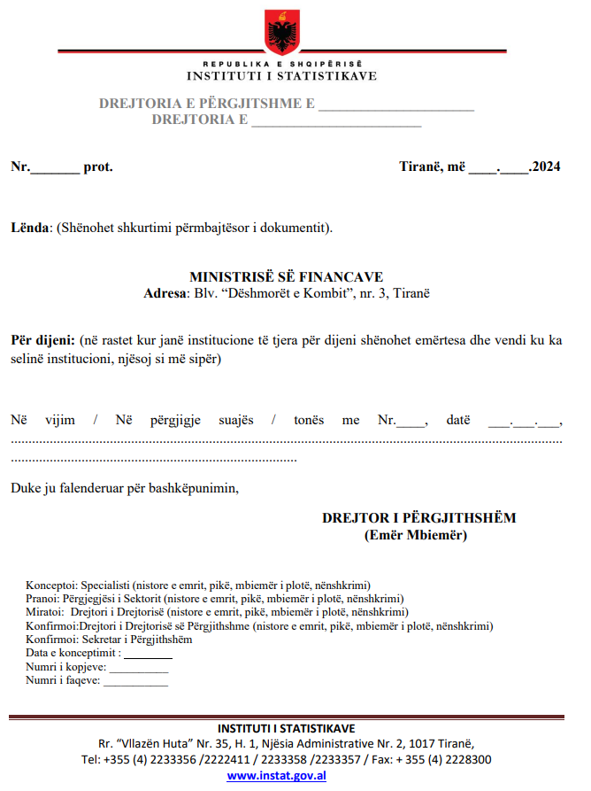

## *Annex 2 – Template of the Official Letter for Internal Correspondence within the Institution and Regional Statistical Offices[163]*

**Annex 3 – Template – Structure of the Quarterly Report**

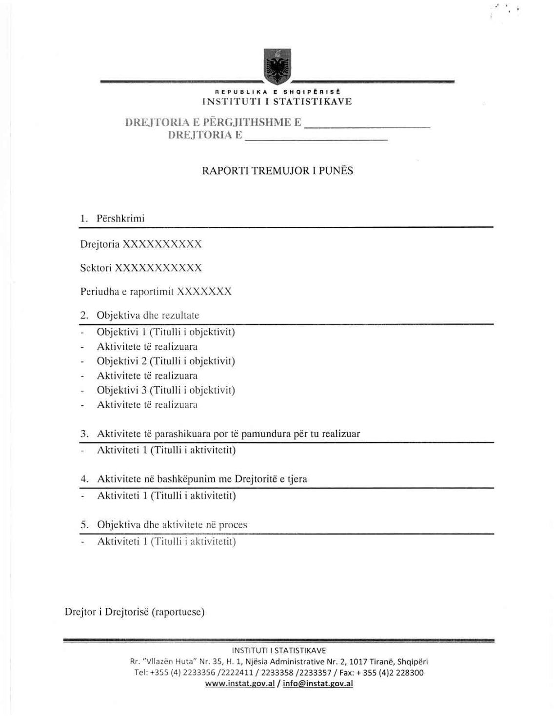

***Annex 4 – Template – Leave Request***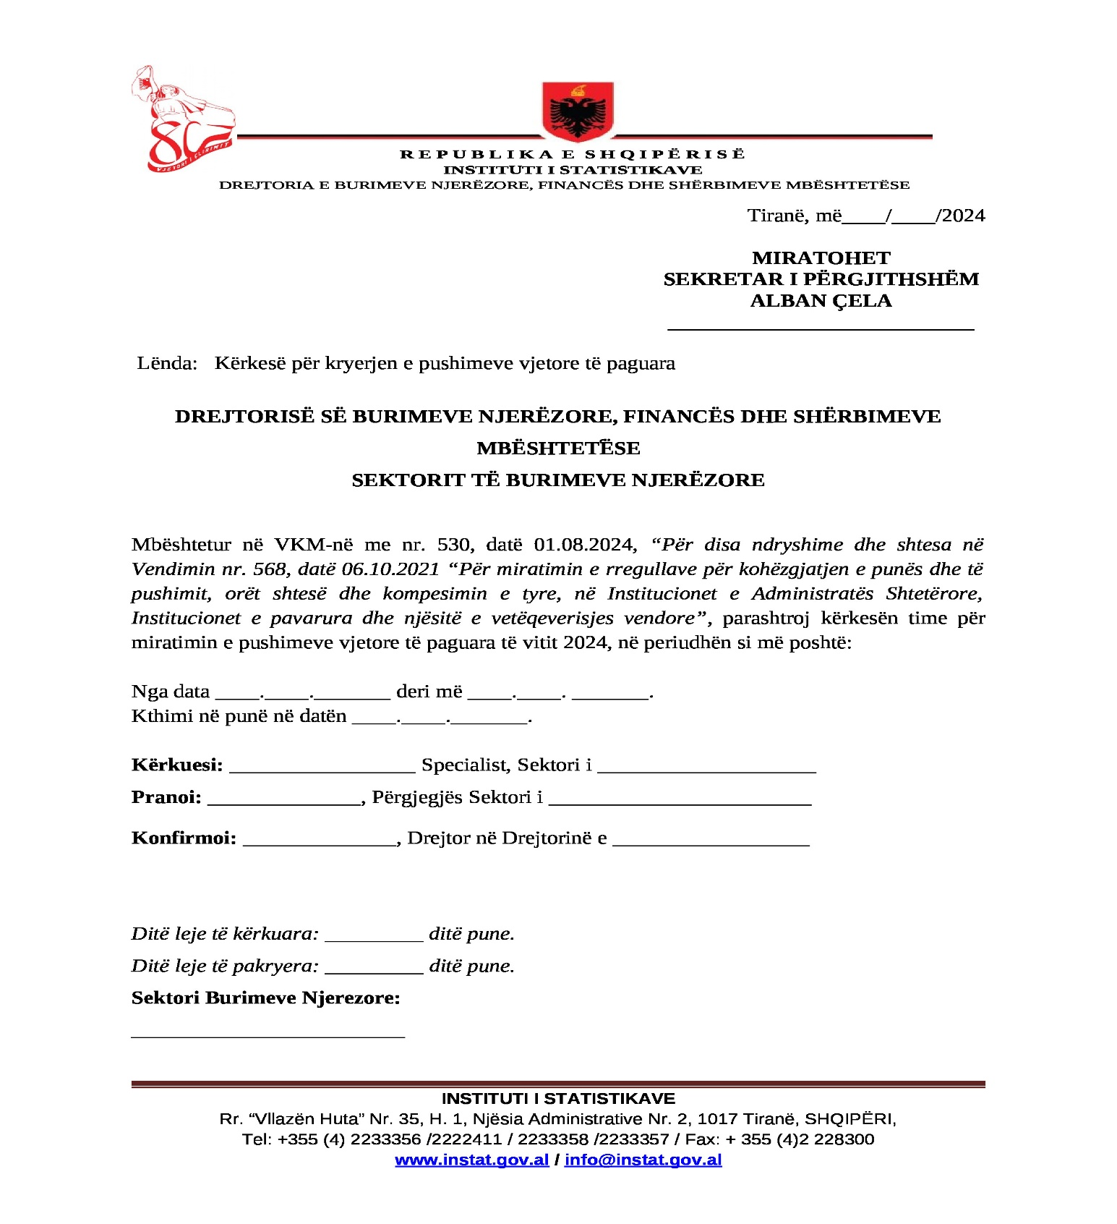

74 Ndryshuar me vendimin nr. 7 datë 04.07.2022

**Annex 5 – Template – Annual Leave Schedule**

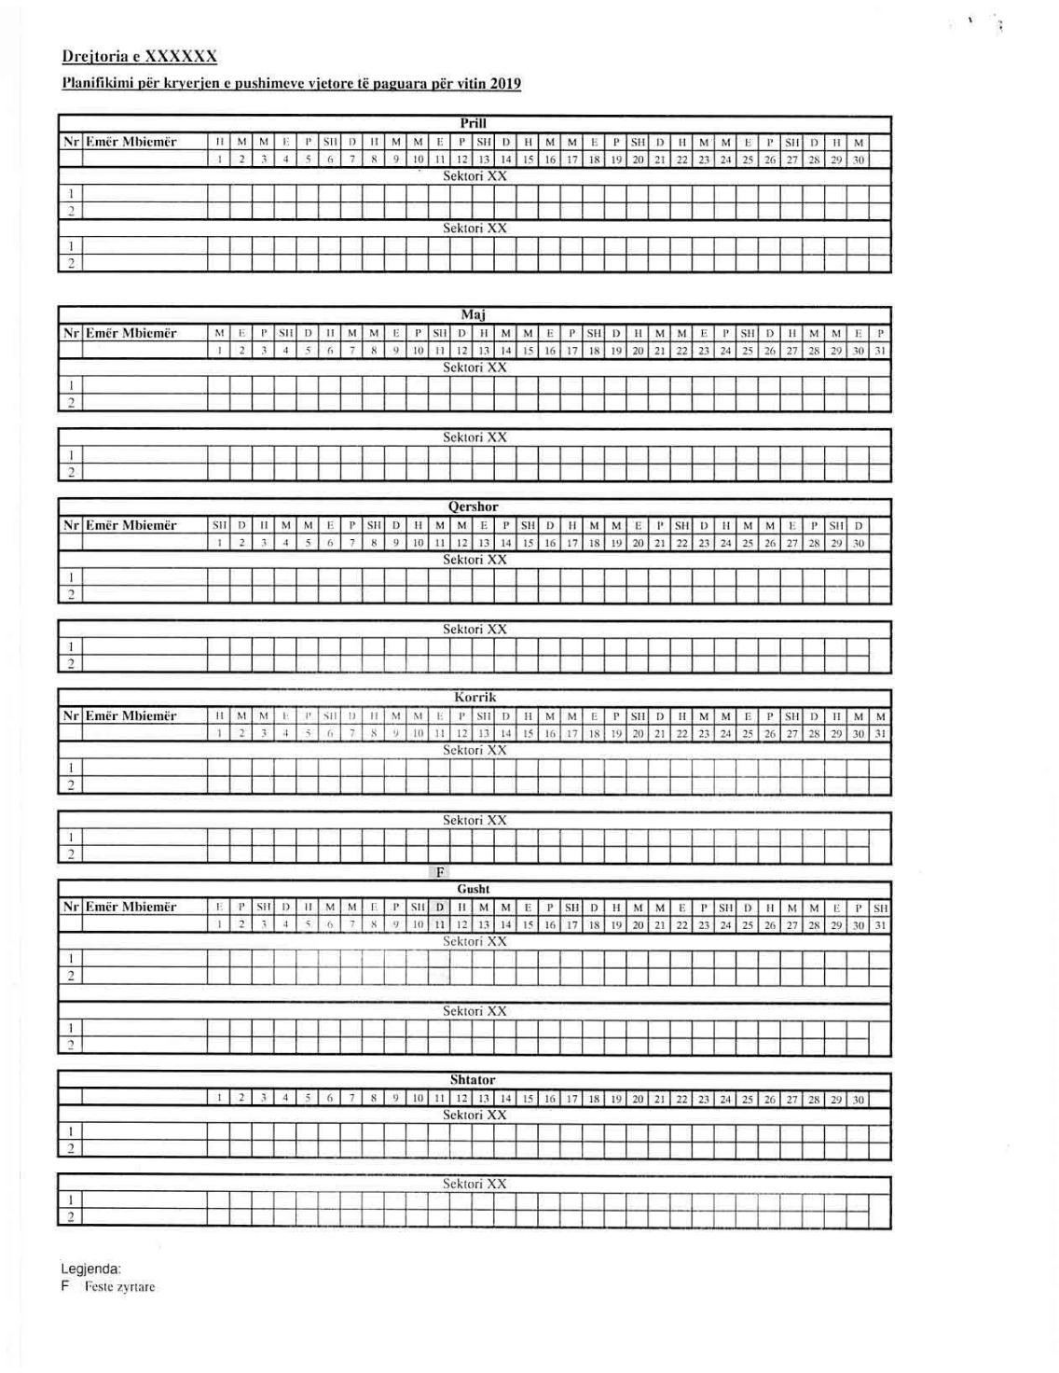

**Annex 6 – Template – Evaluation Form for Civil Servants**

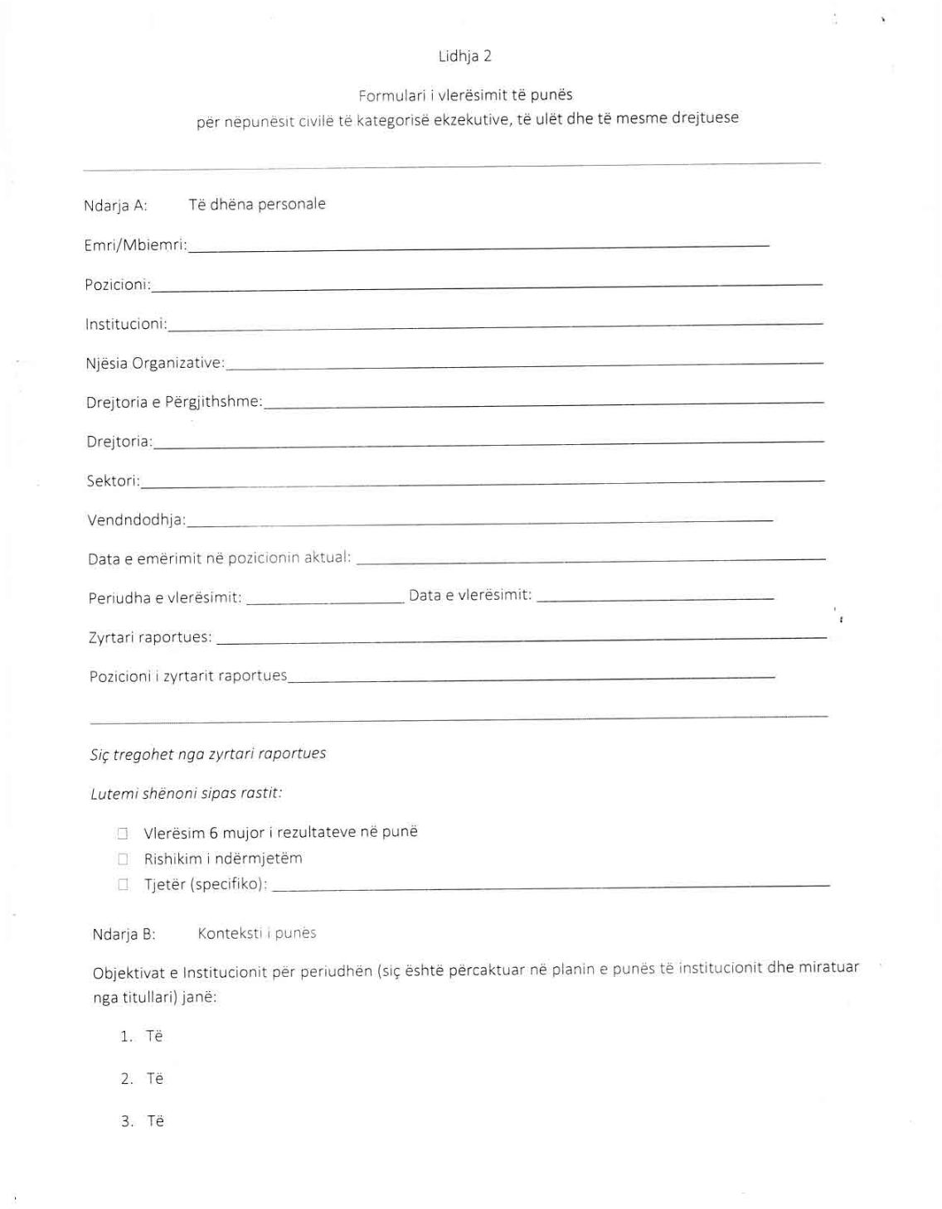

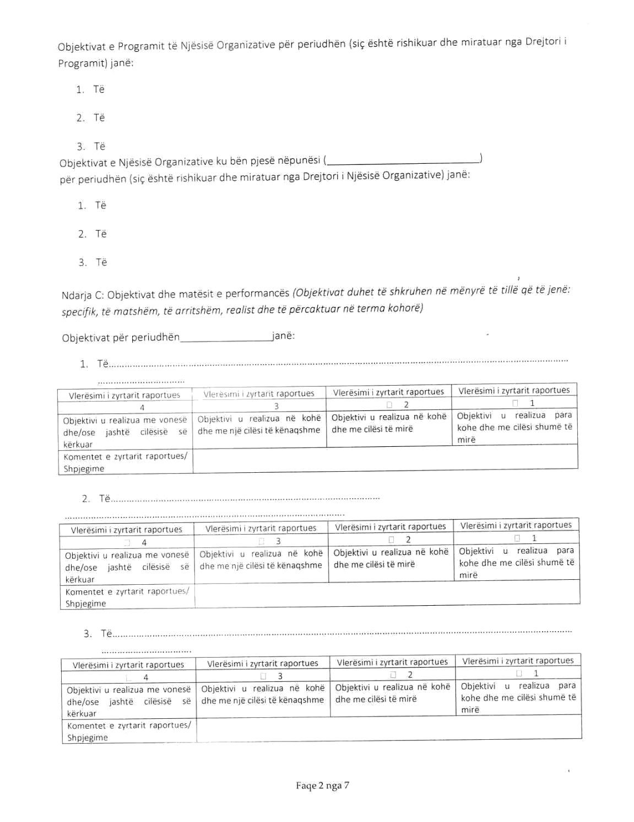

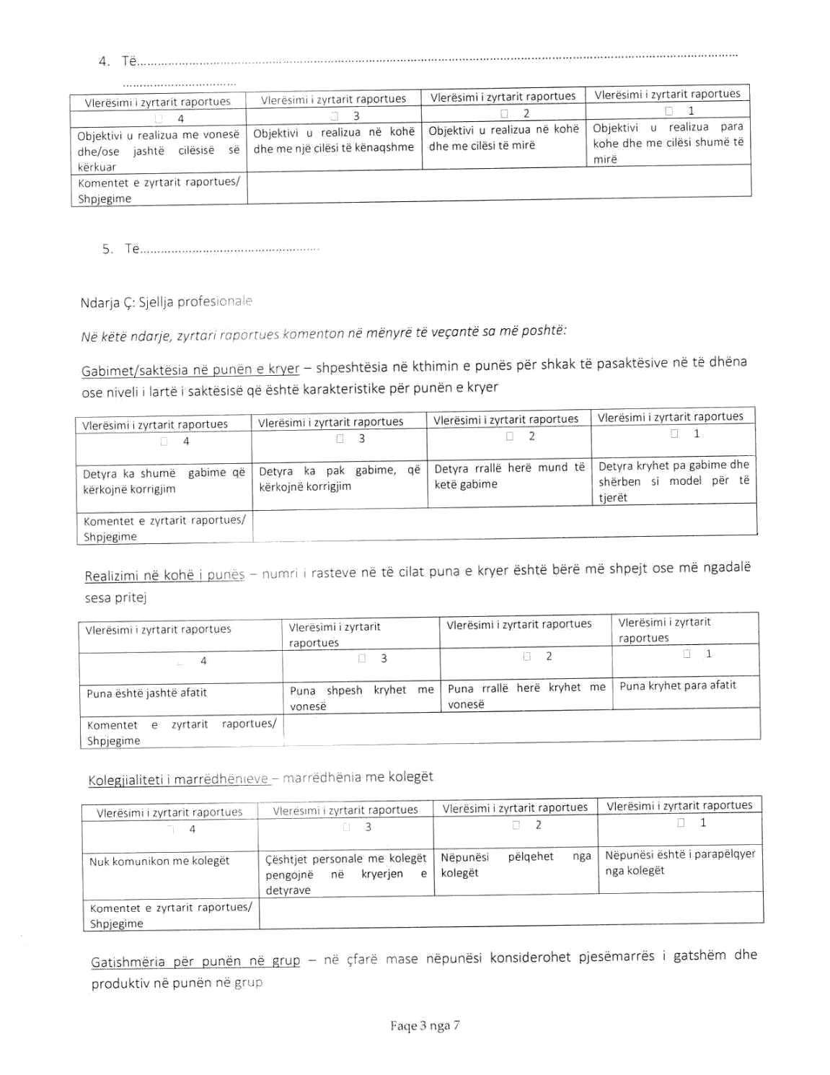

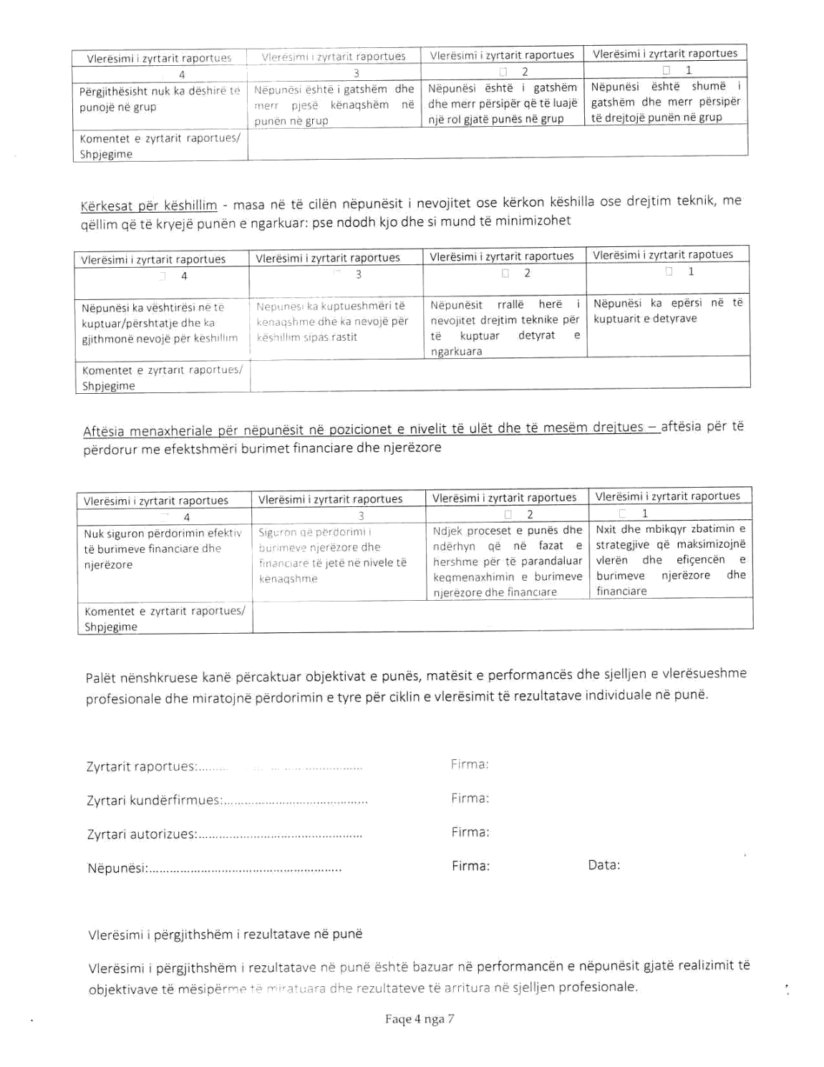

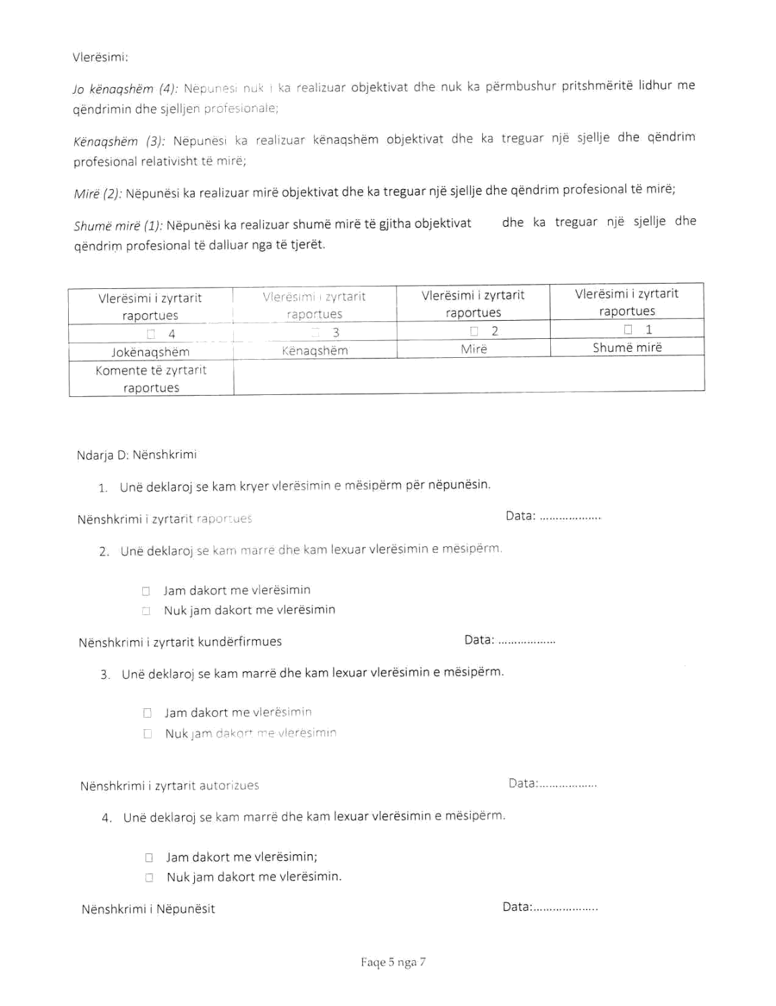

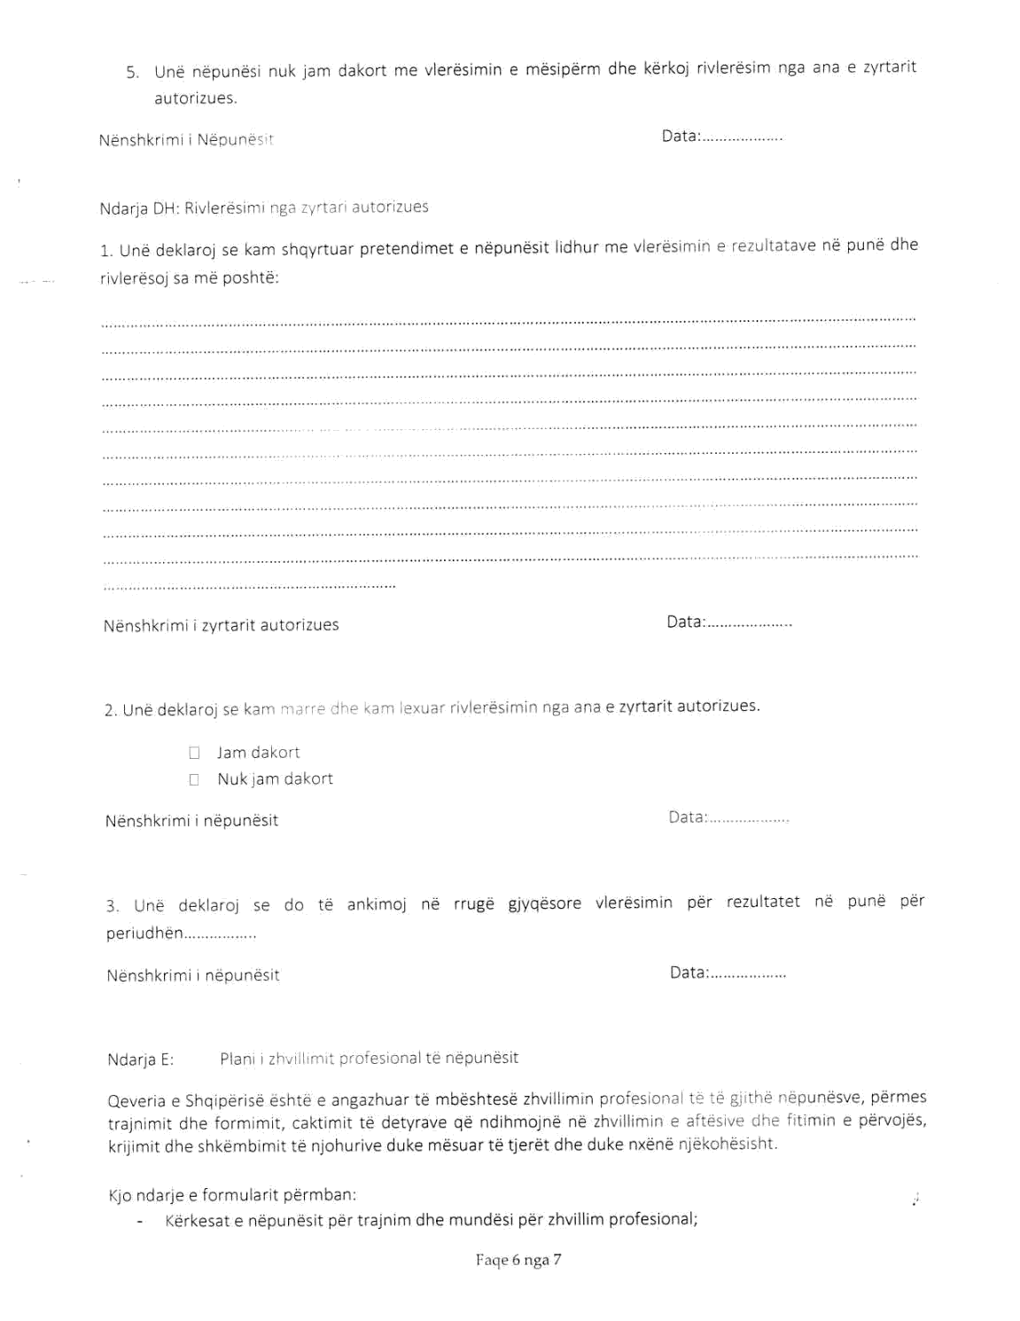

**Annex 7 – Template – Employee Training Sheet***Repealed75*

75 Shfuqizuar me vendimin e nr. 7 datë 04.07.2022

**Annex 8 – Template – Request for Material Resources**

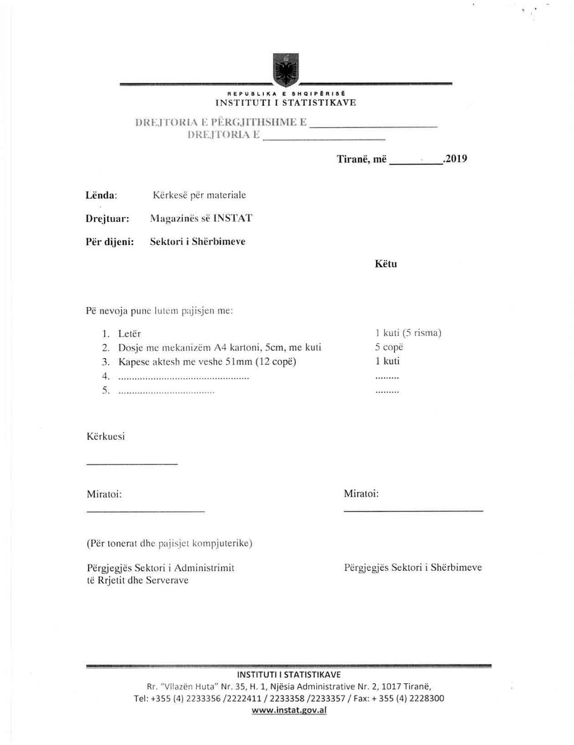

1. Added by Decision No. 5 dated 08.07.2024
2. Added by Decision No. 5 dated 08.07.2024
3. Amended by Decision No. 7 dated 04.07.2022
4. Amended by Decision No. 7 dated 04.07.2022
5. Amended by Decision No. 5 dated 08.07.2024
6. Added by Decision No. 5 dated 08.07.2024
7. Amended by Decision No. 5 dated 08.07.2024
8. Amended by Decision No. 5 dated 08.07.2024
9. Repealed by Decision No. 7 dated 04.07.2022
10. Amended by Decision No. 5 dated 08.07.2024
11. Added by Decision No. 5 dated 08.07.2024
12. Amended by Decision No. 5 dated 08.07.2024
13. The first and second paragraphs amended by Decision No. 7 dated 04.07.2022
14. Amended by Decision No. 5 dated 08.07.2024
15. Amended by Decision No. 5 dated 08.07.2024
16. Added by Decision No. 5 dated 08.07.2024
17. Amended by Decision No. 5 dated 08.07.2024
18. Amended by Decision No. 5 dated 08.07.2024
19. Added by Decision No. 5 dated 08.07.2024
20. Amended by Decision No. 5 dated 08.07.2024
21. Added by Decision No. 5 dated 08.07.2024
22. Amended by Decision No. 5 dated 08.07.2024
23. Amended by Decision No. 5 dated 08.07.2024
24. Amended by Decision No. 5 dated 08.07.2024
25. Amended by Decision No. 5 dated 08.07.2024
26. Added by Decision No. 5 dated 08.07.2024
27. Amended by Decision No. 5 dated 08.07.2024
28. Added by Decision No. 7 dated 04.07.2022
29. Amended by Decision No. 5 dated 08.07.2024
30. Added by Decision No. 7 dated 04.07.2022
31. Amended by Decision No. 7 dated 04.07.2022
32. Amended by Decision No. 5 dated 08.07.2024
33. Repealed by Decision No. 7 dated 04.07.2022
34. Repealed by Decision No. 7 dated 04.07.2022
35. Amended by Decision No. 7 dated 04.07.2022
36. Amended by Decision No. 5 dated 08.07.2024
37. Amended by Decision No. 7 dated 04.07.2022
38. Added by Decision No. 7 dated 04.07.2022
39. Amended by Decision No. 7 dated 04.07.2022
40. Amended by Decision No. 7 dated 04.07.2022
41. Added by Decision No. 7 dated 04.07.2022
42. Added by Decision No. 5 dated 08.07.2024
43. Added by Decision No. 7 dated 04.07.2022
44. Added by Decision No. 7 dated 04.07.2022
45. Added by Decision No. 7 dated 04.07.2022
46. Added by Decision No. 7 dated 04.07.2022
47. Added by Decision No. 7 dated 23.09.2024
48. Amended by Decision No. 7 dated 23.09.2024
49. Amended by Decision No. 7 dated 23.09.2024
50. Amended by Decision No. 5 dated 08.07.2024
51. Amended by Decision No. 7 dated 23.09.2024
52. Added by Decision No. 5 dated 08.07.2024
53. Repealed by Decision No. 5 dated 08.07.2024
54. Amended by Decision No. 5 dated 08.07.2024
55. Amended by Decision No. 7 dated 23.09.2024
56. Amended by Decision No. 7 dated 23.09.2024
57. Added by Decision No. 7 dated 23.09.2024
58. Amended by Decision No. 7 dated 23.09.2024
59. Added by Decision No. 7 dated 23.09.2024
60. Amended by Decision No. 7 dated 23.09.2024
61. Added by Decision No. 7 dated 23.09.2024
62. Repealed by Decision No. 7 dated 23.09.2024
63. Added by Decision No. 5 dated 08.07.2024
64. Added by Decision No. 7 dated 23.09.2024
65. Added by Decision No. 7 dated 04.07.2022
66. Amended by Decision No. 7 dated 04.07.2022
67. Amended by Decision No. 5 dated 08.07.2024
68. Amended by Decision No. 7 dated 04.07.2022
69. Amended by Decision No. 7 dated 04.07.2022
70. Amended by Decision No. 7 dated 04.07.2022
71. Amended by Decision No. 7 dated 04.07.2022
72. Amended by Decision No. 7 dated 04.07.2022
73. Amended by Decision No. 7 dated 04.07.2022
74. Amended by Decision No. 7 dated 04.07.2022
75. Amended by Decision No. 5 dated 08.07.2024
76. Amended by Decision No. 7 dated 04.07.2022
77. Amended by Decision No. 7 dated 04.07.2022
78. Amended by Decision No. 7 dated 04.07.2022
79. Amended by Decision No. 5 dated 08.07.2024
80. Amended by Decision No. 7 dated 04.07.2022
81. Amended by Decision No. 7 dated 04.07.2022
82. Amended by Decision No. 7 dated 04.07.2022
83. Amended by Decision No. 5 dated 08.07.2024
84. Amended by Decision No. 7 dated 04.07.2022
85. Amended by Decision No. 5 dated 08.07.2024
86. Repealed by Decision No. 7 dated 04.07.2022
87. Amended by Decision No. 5 dated 08.07.2024
88. Amended by Decision No. 7 dated 04.07.2022
89. Amended by Decision No. 7 dated 04.07.2022
90. Amended by Decision No. 5 dated 08.07.2024
91. Amended by Decision No. 7 dated 04.07.2022
92. Amended by Decision No. 7 dated 04.07.2022
93. Added by Decision No. 7 dated 04.07.2022
94. Amended by Decision No. 7 dated 04.07.2022
95. Amended by Decision No. 7 dated 04.07.2022
96. Added by Decision No. 5 dated 08.07.2024
97. Amended by Decision No. 5 dated 08.07.2024
98. Amended by Decision No. 5 dated 08.07.2024
99. Amended by Decision No. 5 dated 08.07.2024
100. Amended by Decision No. 5 dated 08.07.2024
101. Amended by Decision No. 5 dated 08.07.2024
102. Amended by Decision No. 7 dated 04.07.2022
103. Amended by Decision No. 5 dated 08.07.2024
104. Added by Decision No. 5 dated 08.07.2024
105. Added by Decision No. 5 dated 08.07.2024
106. Added by Decision No. 5 dated 08.07.2024
107. Added by Decision No. 5 dated 08.07.2024
108. Added by Decision No. 7 dated 23.09.2024
109. Added by Decision No. 7 dated 23.09.2024
110. Amended by Decision No. 5 dated 08.07.2024
111. Amended by Decision No. 7 dated 04.07.2022
112. Amended by Decision No. 7 dated 04.07.2022
113. Amended by Decision No. 7 dated 04.07.2022
114. Amended by Decision No. 7 dated 23.09.2024
115. Amended by Decision No. 7 dated 04.07.2022
116. Amended by Decision No. 5 dated 08.07.2024
117. Amended by Decision No. 5 dated 08.07.2024
118. Amended by Decision No. 5 dated 08.07.2024
119. Added by Decision No. 5 dated 08.07.2024
120. Amended by Decision No. 5 dated 08.07.2024
121. Amended by Decision No. 7 dated 04.07.2022
122. Amended by Decision No. 7 dated 04.07.2022
123. Amended by Decision No. 5 dated 08.07.2024
124. Amended by Decision No. 5 dated 08.07.2024
125. Amended by Decision No. 7 dated 04.07.2022
126. Amended by Decision No. 7 dated 04.07.2022
127. Amended by Decision No. 5 dated 08.07.2024
128. Amended by Decision No. 7 dated 04.07.2022
129. Added by Decision No. 5 dated 08.07.2024
130. Added by Decision No. 5 dated 08.07.2024
131. Amended by Decision No. 5 dated 08.07.2024
132. Added by Decision No. 5 dated 08.07.2024
133. Amended by Decision No. 7 dated 04.07.2022
134. Amended by Decision No. 5 dated 08.07.2024
135. Amended by Decision No. 5 dated 08.07.2024
136. Amended by Decision No. 5 dated 08.07.2024
137. Repealed by Decision No. 7 dated 04.07.2022
138. Added by Decision No. 5 dated 08.07.2024
139. Amended by Decision No. 5 dated 08.07.2024
140. Amended by Decision No. 5 dated 08.07.2024
141. Amended by Decision No. 5 dated 08.07.2024
142. Amended by Decision No. 5 dated 08.07.2024
143. Amended by Decision No. 5 dated 08.07.2024
144. Added by Decision No. 5 dated 08.07.2024
145. Added by Decision No. 5 dated 08.07.2024
146. Amended by Decision No. 7 dated 04.07.2022
147. Added by Decision No. 5 dated 08.07.2024
148. Amended by Decision No. 5 dated 08.07.2024
149. Added by Decision No. 5 dated 08.07.2024
150. Amended by Decision No. 7 dated 04.07.2022
151. Amended by Decision No. 5 dated 08.07.2024
152. Added by Decision No. 5 dated 08.07.2024
153. Added by Decision No. 5 dated 08.07.2024
154. Amended by Decision No. 7 dated 04.07.2022
155. Amended by Decision No. 7 dated 04.07.2022
156. Amended by Decision No. 5 dated 08.07.2024
157. Added by Decision No. 5 dated 08.07.2024
158. Amended by Decision No. 7 dated 04.07.2022
159. Amended by Decision No. 5 dated 08.07.2024
160. Amended by Decision No. 5 dated 08.07.2024
161. Amended by Decision No. 5 dated 08.07.2024
162. Amended by Decision No. 5 dated 08.07.2024
163. Amended by Decision No. 5 dated 08.07.2024