General instructions for using the statistical database of INSTAT

# Introduction

The Statistical Database of the Institute of Statistics provides access to data that Instat produces from administrative or statistical sources. The database is organized by sub-topics of statistical themes and can be accessed in the link: [Statistical Database](http://databaza.instat.gov.al/pxweb/en/DST/)

Tables in PC-Axis format allow:

* direct access via a web interface,
* the ability to choose different data dimensions
* the ability to choose different data dimensions and the storage of tables in different formats for further use.

In this document you will find instructions for:

* Ways of accessing data,
* The ability to preview the selected data in PC-Axis format.
* Downloading data to the desired format
* Using special icons to select the desired variables or contents
* Use of data in graphical form and tables

**Figure 1:** *Statistical Database*

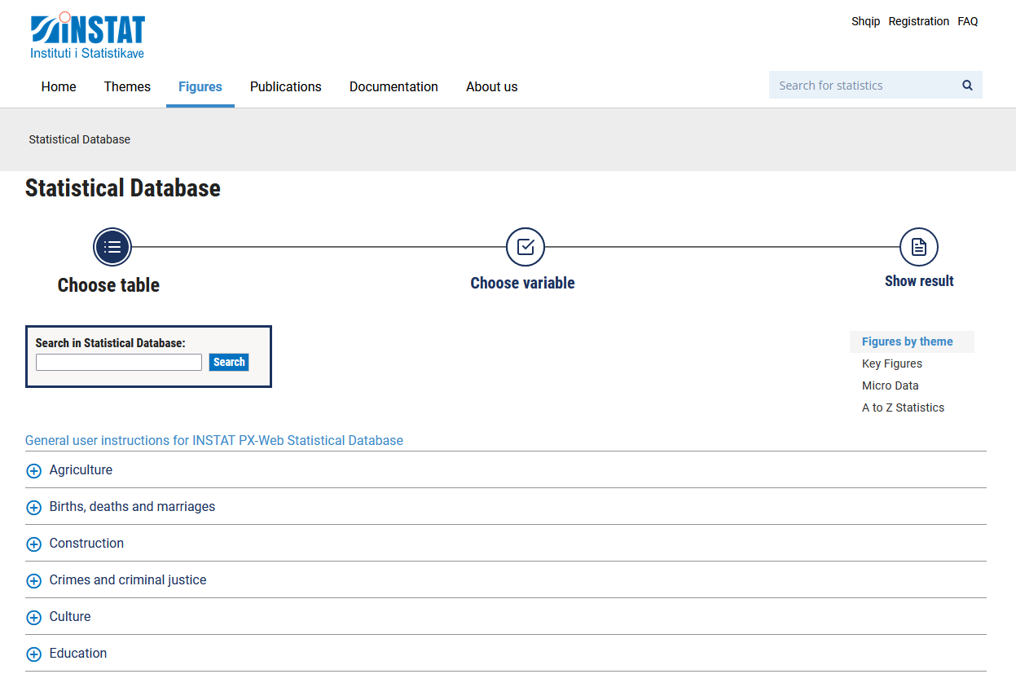

# Creating tables

In the statistical database, the table is created in 3 simple steps:

**Figure 2:** *The steps of creating a table*

## Choosing the table

To select a table, we should go to the required sub-topic (1). Then we select the name of the table (2).

**Figure 3:** *How to choose a table*

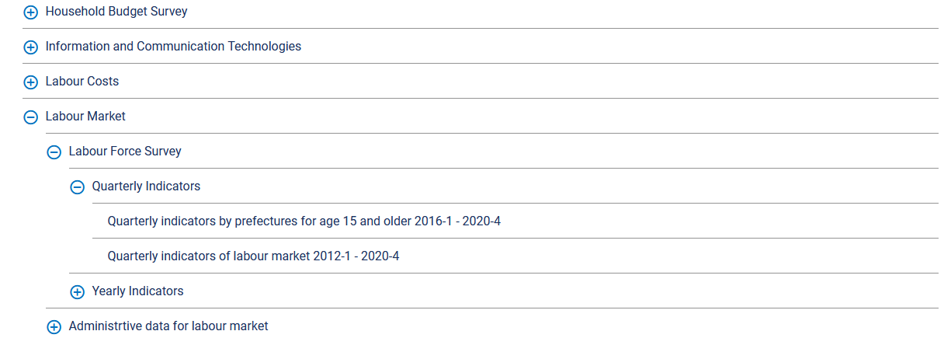

**1**

**2**

**Choosing variables**

After selecting the desired table, the next step is "Selecting variables", where the indicators and variables according to which these indicators will be displayed, can be specified.

The first choice to make is the statistical variable (indicator). All tables have at least one statistical variable. Click to select one or more of these variables (1).

Also, there are one or more classification variables (dimensions). The available values are listed in the respective boxes (2).

**Figure 4:** *Choose variables*

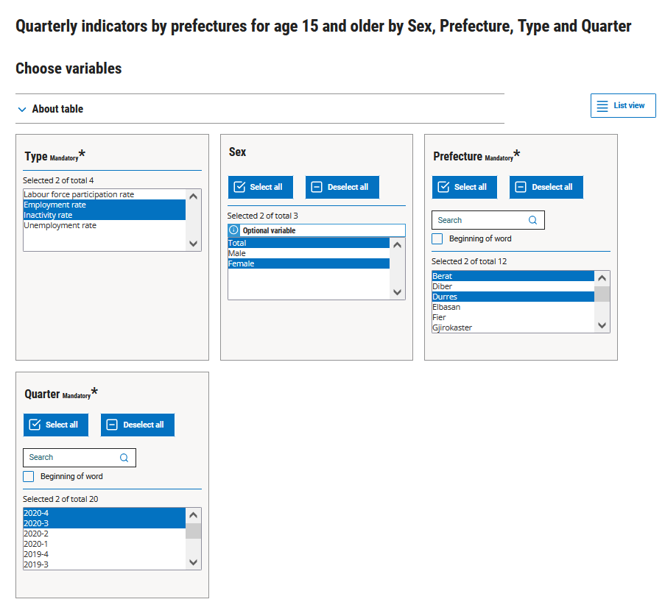

1

2

2

2

There are several ways to select more than one value from the list of indicator options and classification variables.

2

*Non-consecutive values*: Hold down the Ctrl key while clicking on the desired values.

*Successive values:*

* Swipe with the mouse by right-clicking.
* Click on a value and then hold down the Shift key while selecting the next value that determines the range of options that will be displayed.

Choosing all possible options: Click on the button “**Select all**”.

Remove all selected variables: Click on the button “**Deselect all**”.

To search for a certain value of the variable: Click on the textbox “**Search**”.

For some variables, if we do not choose any value, the indicator fot the total will be displayed. For example if we don’t specify a value for the *Gender*, the selected indicator will be shown fot the *Total* option of this variable.

***Careful***: You must select at least one option from the Time variable.

## Show table

Once you have selected all the values you want to appear on the table, click “*Show table*”. Below this button you can also see how many cells your table has. The maximum number of cells allowed is 100.000. The on-screen display is limited to 1.000 lines and 30 columns.

**Figure 5:** *Display of the number of cells selected*



The result of the combinations of indicators and selected dimensions, gives the table below:

**Figure 6:** *Table with indicators and selected dimensions.*

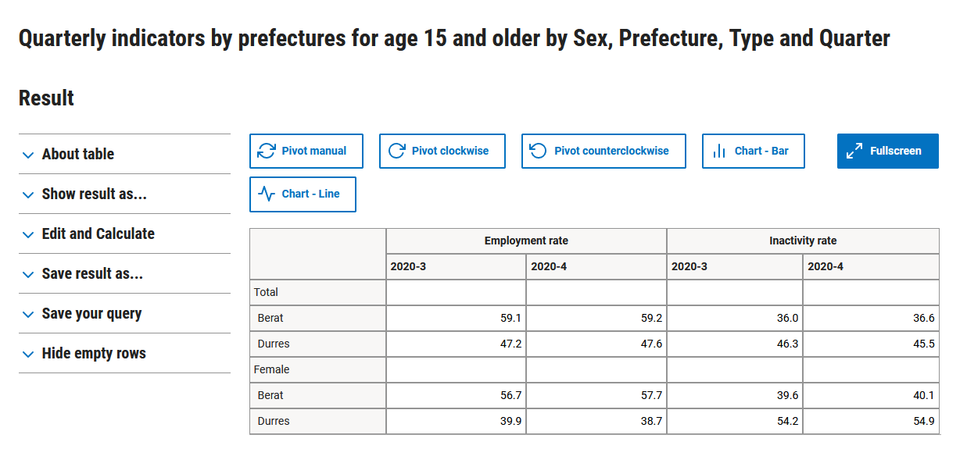

In “*Hide empty rows*” menu you can personalize related to the rows with zeros or dots.

**Figure 7:** *Hide empty rows*

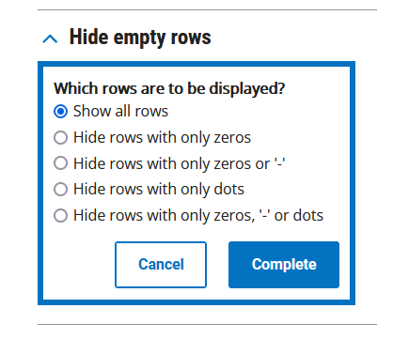

In “*About table*” menu, you can find information about source of data of the table and units of measure used.

**Figure 8:** *About table*

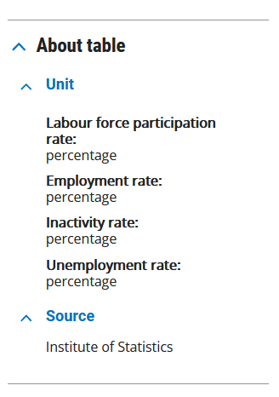

Some options offered for customizing and storing the table are provided below.

### Transpose the table

The table can be modified by changing the variables that you want to appear on rows and columns, using the buttons Pivot manual, Pivot clockwise or Pivot counterclockwise.

**Figure 9:** *Transposition of the table*

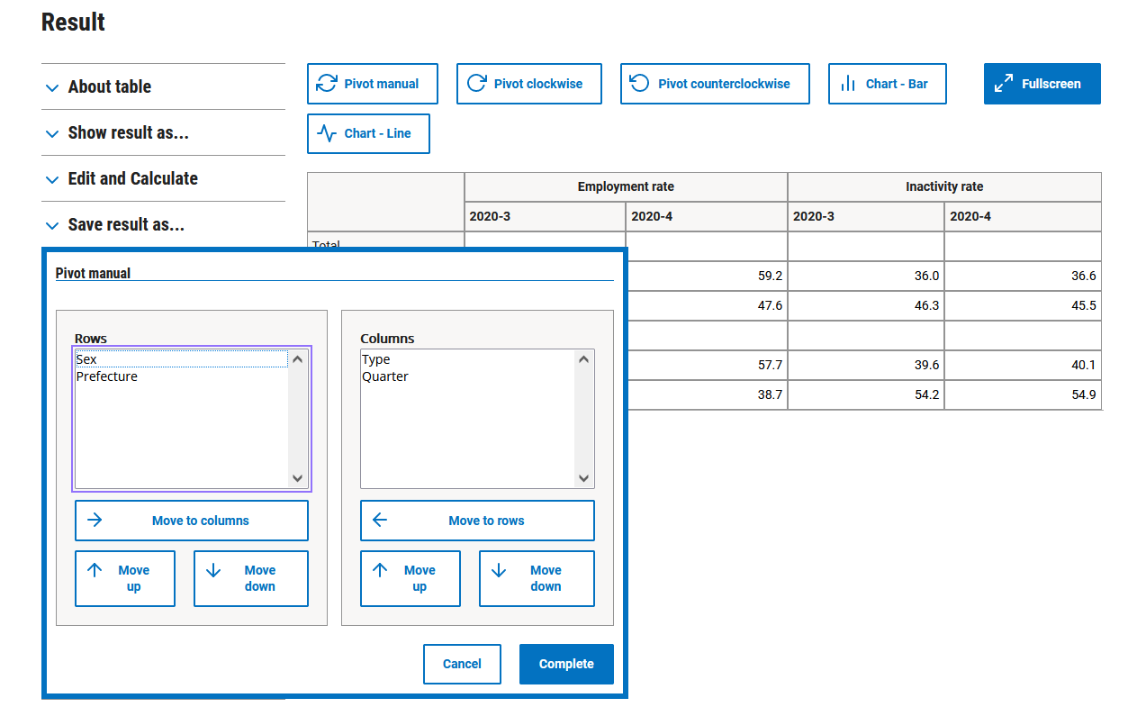

You can use Move to columns and Move to rows buttons, to change the variables in rows with those in the columns.

In the “*Edit and Calculate*” menu, there are various options for modifying the table.

**Figure 10:** *Modify the table*

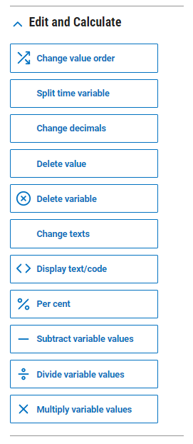

### Saving the table

In the menu “*Save result as*...” various formats are displayed in which the table can be saved and downloaded.

**Figure 11:** *Downloading the table in different formats.*

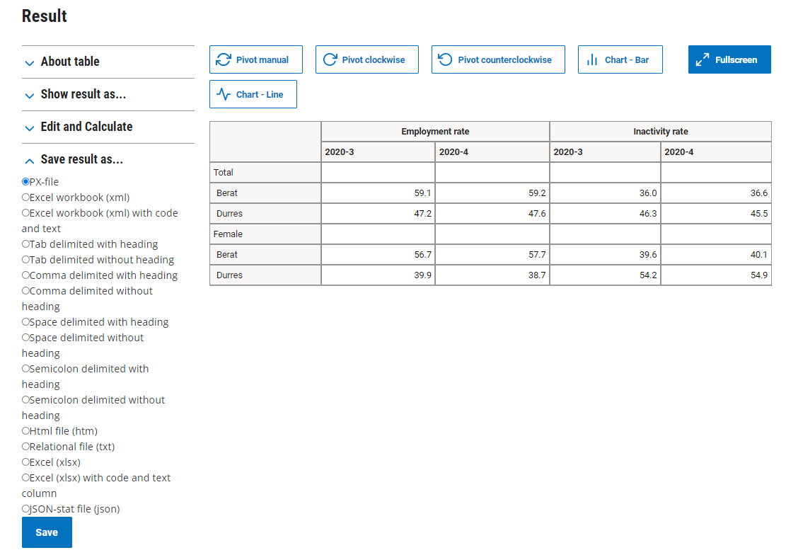

In the window where the table appears, you can choose to view the data in a graphic.

**Figure 12:** *Chosing the way data is presented*

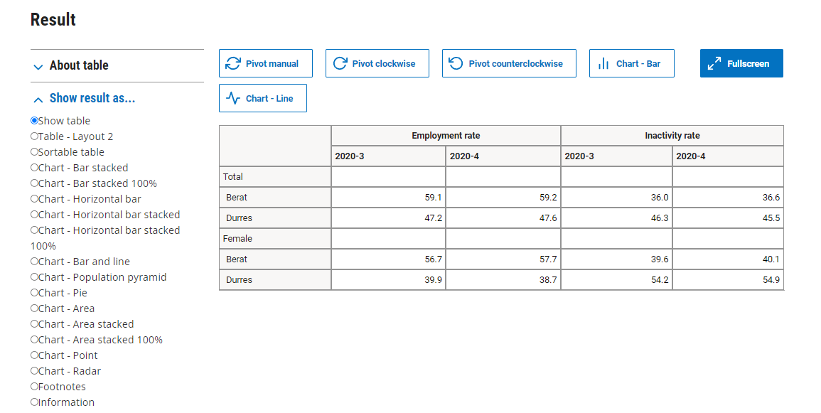

**Figure 13:** *Graphical data of display*

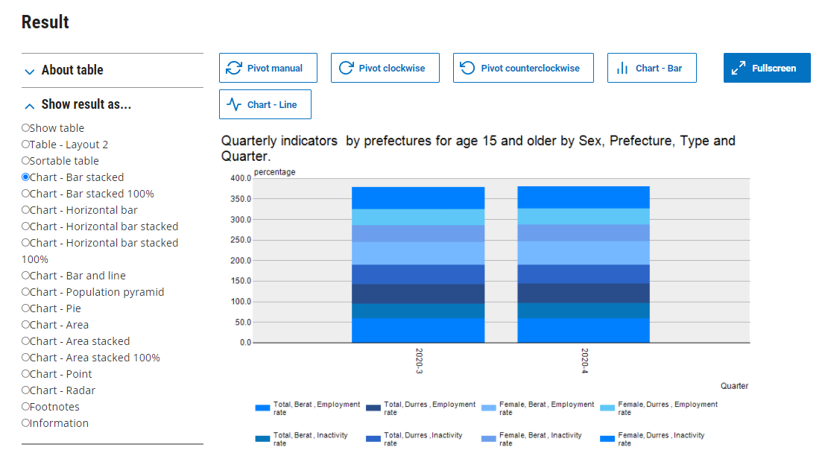

If you choose a graphical display, in the menu “*Chart settings*”, you can change the size, title, etc.

**Figure 14:** *Chart settings*

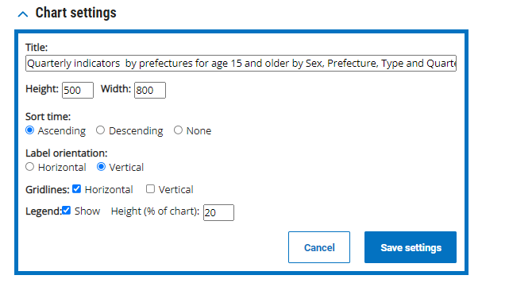

### Saving the query

Once new time series are added to the required data table, we can choose to update the query by changing only the initial time period, keeping the initial time period unchanged, or not updating the query. The format is selected and the query can be saved by copying or sending as e-mail.

**Figure 15:** *Saving the query*

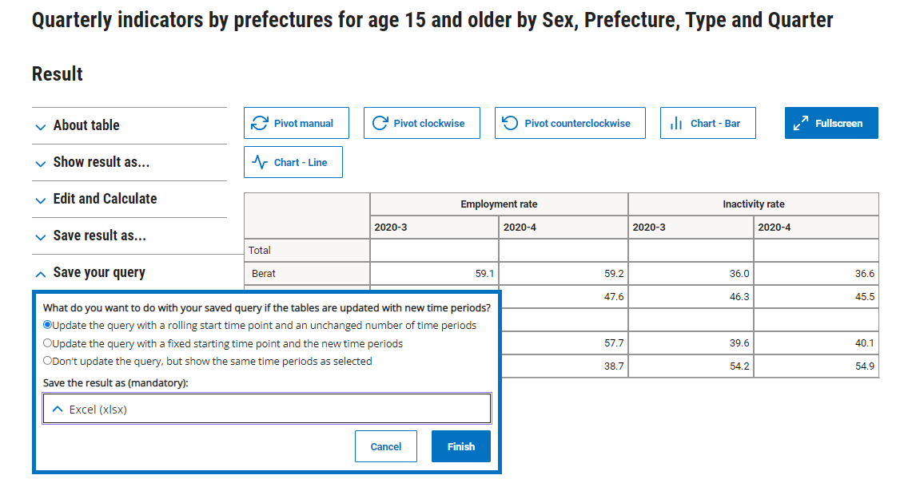

**Figure 16:** *Saved query*

